**ANNEX VI**

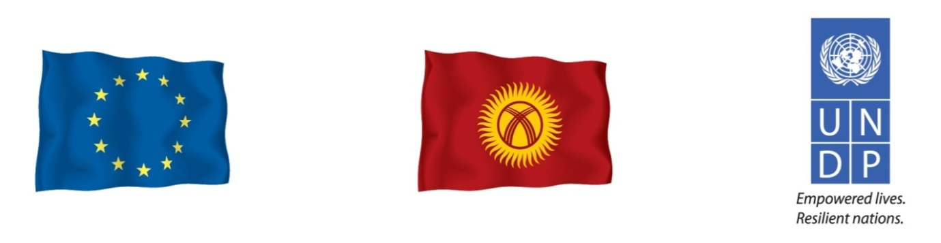

Support to Operationalization of the Constitutional Chamber of the Supreme Court of the Kyrgyz Republic

Annual Progress Report

1. **DESCRIPTION**
   1. Name of beneficiary of grant contract: United Nations Development Programme
   2. Name and title of the Contact person: Mr. Alexander Avanessov, UNDP Resident

Representative in the Kyrgyz Republic

* 1. Name of partners in the Action: N/A
  2. Title of the Action: Support to Operationalization of the

Constitutional Chamber of the Supreme

Court of the Kyrgyz Republic

* 1. Contract number: IFS-RRM/2013/331-462
  2. Start and end date of the reporting period:November 15, 2013 – February 15, 2014
  3. Target country(ies) or region(s): Kyrgyz Republic
  4. Final beneficiaries &/or target groups (if different) *(including numbers of women and*

*men):*

* + 1. The primary target groups of this project are: (1) the judges and staff of the CC; (2) legal professionals, courts, prosecutors, the Bar, and universities; (3) civil society organizations and activists working to strengthen rule of law and democracy; (4) the Office of the President; (5) the Parliament, its sections, and selected committees; (7) the Government and its ministries; (6) the Ombudsman; (7) local self-governments; 8) media organizations and journalists.
    2. The citizens of the Kyrgyz Republic and their communities, which are served by those target groups listed in 1.8.1, are the indirect, but final beneficiaries of this project.
  1. Country(ies) in which the activities take place (if different from 1.7):

1. **ASSESSMENT OF IMPLEMENTATION OF ACTION ACTIVITIES**
   1. EXECUTIVE SUMMARY OF THE ACTION

The project titled “*Support to Operationalization of the Constitutional Court (Chamber) in the Kyrgyz Republic*” (hereinafter, simply “the Project”), has been instrumental in re-launching long-needed constitutional justice in the Kyrgyz Republic, which was forcefully interrupted during the events of 2010. This initiative, which is funded by the European Union (*“the EU”*) and implemented by UNDP, facilitates strengthening the rule of law and stability in the Kyrgyz Republic by creating a professional, competent, and independent Constitutional Chamber *(“the CC” or “the Chamber”),* which in turn will help to establish a new tradition of judicial impartiality and full accountability in its service to the citizens of the Kyrgyz Republic.

Indeed, this effort to support the CC has been a regular contribution to social stability and to the creation of a more sustainable, long-lasting peace in the country. The project helps the CC in a difficult period of its history to become fully functional, develop and abide by high quality performance standards, and garner the trust and legitimacy necessary for successfully fulfilling its role as the final authority and guarantor of the Constitution and a defender of human rights. The efforts of this project are essential, especially against the background of a fragile peace which exists in the Kyrgyz Republic; though conflict and violence at the levels seen in 2010 are not observed on the streets today, their causes – which have included perceptions of an illegitimate or dysfunctional legal system leading to unequal application of the rule of law – still remain.

Despite having just been started a year ago, the Project has already managed to demonstrate its relevance, necessity, effectiveness, and correspondence to the needs of country; it also made some sustainable inputs of a long-lasting nature. The Project was in line with the requirements of the beneficiary, and was implemented in close collaboration with the judges and staff of the CC. The Project also made efforts to create a more favorable environment for the performance of the CC, as well. Further, it has increased awareness among key political actors, state institutions, representatives of the legal community, and civil society of the roles and functions of the CC, and of the importance of respecting and protecting human rights, duly abiding by the Constitution, and ensuring the separation of powers necessary for a successful democracy. The CC is gradually assuming its appropriate position among the branches of government, and has, importantly, begun to accumulate experience functioning in a parliamentary democracy. The institution is striving to become a more independent, transparent, and professional organization, facilitating the implementation of international covenants and standards into national practice. The Chamber is beginning to serve as an institution that safeguarding the Constitution and appropriatelyprevents illegal, socially destabilizing activities as well.

This EU and UNDP effort has been instrumental in building up a new organization, improving its internal management, structure, and business processes, and facilitating the implementation of its functional responsibilities and the mission. The Project has also helped to provide accelerated training to, and thereby increased capacity of, judges and staff of the CC, the accumulation of best international practices, as well as the fostering of cooperation with the constitutional courts of other countries, the Venice Commission of the Council of Europe *(“the VC”*), and the European Court of Human Rights. Technical infrastructure was improved by procuring necessary equipment, arranging audio record keeping systems, and similar actions.

All of these interventions have significantly increased the efficiency and speed of the work of the CC. When compared to the previous constitutional court, the transparency of activities of the new Chamber has greatly improved, as well: now, the CC has its own fully operational website, and the decisions of the CC are published and made publicly available within three days of their adoption. Workshops and conferences are also conducted with the participation of the legal community, academia, defense attorneys, and human rights activists, as well as with decision-makers from the Parliament, the Office of the President, and the Office of the Government of the Kyrgyz Republic.

Overall, significant progress has been made in the development of the CC, and it is clear that this progress would not have been achieved without the comprehensive, targeted support of the Project; the usefulness of this project has been repeatedly highlighted by judges and staff of the CC, as well as by notable representatives of civil society. Yet while the clear successes of Project are rightly laudable, and will ultimately help to improve rule of law and strengthen democracy in the Kyrgyz Republic, more work lies ahead, as additional difficulties in the full operationalization of the Chamber remain and require the attention of the donor community.

* 1. RESULTS AND ACTIVITIES (R & A)

*What is your assessment of the results of the Action so far? Include observations on the performance and the achievement of outputs, outcomes and impact in relation to specific and overall objectives, and whether the Action has had any unforeseen positive or negative results.*

An assessment of the Project for the review period yields positive signs. Many relevant outputs were achieved and encouraging, long-term effects are observed. The results of Project activities confirm that consistent progress in achieving intended target indicators is being made. This has become possible by way of committed activities, a clear vision for how the Project is to be implemented, the availability of a competent and knowledgeable project staff, availability of international expertise from the VC, support from the management and various subdivisions of the EU and UNDP, cooperation with the CC and other stakeholders, cost optimization, and other essential factors. Therefore, we remain reasonably optimistic this project will achieve its aims with its further implementation and eventual completion.

Specifically, meaningful success in increasing the capacity of the CC has been achieved, as well as in the study of relevant European and international practices of constitutional courts. The EU and UNDP Project helped greatly to raise the skills and potential of judges and staff of the CC from the level observed at the Project’s inception stage in 2013. This result is important because the competence of individual judges and staff determines the success of the institution they serve. This result should also be taken in view of the fact that the majority of judges have no previous experience working with the constitutional justice authority; the administration has only been recently established and staff did not originally have enough qualifications to properly perform their tasks. Tailored trainings arranged by the Project helped educate 80% of judges, and between 40% and 65% of the administrative staff, depending on the training subject being considered. These trainings resulted in higher quality decisions being delivered by the CC and to stronger content in the reasoning *(declarative, justification)* part thereof. Judges now more frequently draw on related international experiences and refer to applicable international laws as they review cases. Additionally, the staff of the administration raised their analytical skills and benefited from experience in drafting analytical papers.

Within one year of its existence, the Chamber has pronounced 39 decisions, which is an unprecedented amount for a constitutional court in the Kyrgyz Republic. In the 17 years that the previous court operated before it was abolished in 2010, it had made only about 169 decisions – an average of roughly 8 decisions each year. Certainly, the high number of decisions pronounced by the new Chamber in just one year could be an indication of an increase in violations of the Constitution; however, it can also indicate a real need for legal aid, and also of the growing authority and legitimacy of the CC and its decisions.

For the first time in its history, the Chamber has started to conduct trainings for its judges and staff, develop a plan of its own further development, reflect on its communication strategy, and educate human rights activists, defense attorneys, and journalists on its function and procedures. Fifteen court-tailored seminars and trainings were conducted for judges and staff of the CC, out of which five seminars were conducted with direct engagement of the VC and its knowledgeable experts. International experiences administering constitutional justice were explored as well, supported by three study visits to constitutional courts, the VC, and the European court of Human Rights. Additionally, three memoranda on cooperation were signed with various constitutional jurisdictions. According to the statistics of the Project, exchange of experience with 50 international experts of constitutionalism, law, transparency, and strategic development, as well as with judges and staff of constitutional courts from other countries, were arranged. Those consulted include experts of the VC as renowned international organization in the area of constitutional justice and rule of law.

During the reporting period, the CC and other stakeholders, with the assistance of the Project, organized 52 public events aimed at supporting the activities of the CC *(note: this figure does not include brief meetings or face-to-face consultations, which were also of critical importance, despite their more limited scope).* It should be noted that while the Project did not specifically focus on increasing the *number* of participants in these events – indeed, of greater importance to the Project was the *quality* of people’s participation achieved through more effective, targeted approaches – some 1,500 people participated.

The Project also had the effect of advancing a number of important issues to higher levels of government for further consideration and incorporated CC-related issues into high level policy documents. For example, the Project highlighted for key government actors the challenges of enforcing decisions made by the Chamber, of rule of law implementation in the country, including the Constitution, on the role and functions of constitutional chamber, its independence, political expediency, and the importance of eliminating political pressure on CC judges by the Parliament, the President, the executive, and other actors. All these issues have also become the subjects of roundtables, parliamentary debates, parliamentary committee deliberations, and high-level meetings that have included the President, members of the government, as well as other leaders. In fact, enforcement of decisions of the CC was the subject of a recent legislative initiative and its relevant bill is expected to be submitted for the review of the Jogorku Kenesh *(the Kyrgyz Parliament)* in the near future.

Compared to the Project’s inception period, the perception of the Chamber in the wider public is gradually improving. Civil society has begun to better understand its related role and functions, while the number of petitions to the Chamber has increased.

The high level of established cooperation between the Project and the Chamber also deserves mentioning in this report. Motivation of and support from the Chairman of the Chamber, its judges, and staff are of great importance to the success of the Project’s aims.

The positive results attained to date are surely encouraging signs for the Project, even when considering certain unforeseen problems faced at different times in the reporting period (*detailed later in this report*). With these activities, the Project has been steadily changing the environment around the Chamber, raising the capacity of one of the most prominent national institutions situated to ensure the rule of law, as well as increasing awareness and understanding of the Constitution. It is vital that we not to stop at this stage, but rather continue progressing systematically toward the full achievement of this Project’s stated goals.

*Unforeseen Positive Results*

In the course of the Project’s implementation, certain unexpected, but truly positive conditions and outcomes have been produced. Here are some examples:

* Good level *of motivation of the Judges and staff* to implement the tasks assigned to them, and to demonstrate good results to the public they serve. **This is an internal force which is quite useful for the implementation of any donor projects, including the one under review in this report**;
* The majority of judges of the CC, who are of a younger generation and not as set in conventional ways, are oriented toward what are considered new, modern standards of performance. Indeed, they show they are ready for change, which significantly facilitates the implementation of the Project;
* Instead of only drafting the first programmatic budget for the CC as planned, the Project actually managed to produce the first programmatic budget for the *entire* judicial system for 2015.This achievement was in fact necessary, as the budget of the CC is an integral part of the broader judicial system encompassing the Supreme Court, the CC, the local courts, the Judicial Department, and the training center for judges. Drafting of a programmatic budget for the CC would have been impossible without taking into account budgets of all of these other entities at the same time. Therefore, the Project did more than initially envisioned and with a greater effect. Assistance from the EU and UNDP in this particular period in fact proved to be highly relevant: at this time, the judicial system was unable to draft on its own a budget in the programmatic format, due to lack of properly trained specialists. More than 100 persons representing all these institutions were brought in to the process, resulting in the first programmatic budget of the judiciary being drafted and adopted by the Jogorku Kenesh (*more details are provided later in the relevant section of this report*).

*Unforeseen Negative Results*

Certain events of 2014 nonetheless also inevitably contributed to some negative results for the Project. These include the following:

* *Vacancies remain in the Chamber*. Law requires that the CC be composed of 11 judges who work in a collegiate manner. By the time of the Project’s inception, however, only nine judges had been elected, a number which was unfortunately reduced to eight with the death of one of the judges during this reporting period. Exactly eight judges are required to establish a quorum for decision-making and the legitimate performance of the CC responsibilities *(a lower number of judges is not permitted).* Minimal membership negatively impacts the Project for several reasons. Firstly, it has made it difficult to conduct Project events because some judges were unable to participate in the interventions, as their absence at a sitting would have led to the CC being unable to establish a mandated quorum. Clearly, the activities of the Project were dependent on the work schedule of judges, and occasionally those activities were forced to be delayed. Secondly, the failure to appoint three new judges to vacant positions of the CC has deprived those individuals of the opportunity to take advantage of trainings and assistance offered by the Project. They have already missed a number of Project training events, and it still is not clear when they will be appointed. Therefore, there is a risk that in such situation the Project will not succeed in providing training to these three at all. It is also evident that the difference between judges in education, capacity, and understanding of constitutional issues and international standards undermines the chances for a collegiate and collaborative work and for collective decision-making. Thirdly, with less judges in the Chamber, there is greater chance that any pressures or attractive career proposal placed on even just one could paralyze the activities of the whole institution;
* *Insufficient collaboration*, inter-personal communication between judges, culture of constructive debate, consensus-building, and collective decision-making, as well as a difference in the capacity and values among judges, have also proven to be obstacles. Regrettably, the judges presently in the CC are split into various segments and very often demonstrate incompatible views. Practically each decision of the CC made in the 2013-2014 period was accompanied by one, two, or even three dissenting opinions, which has shown that the judges failed to find a common approach. These divisive dynamics create a significant obstacle to agreement on the Project’s activities, as well as for the scheduling of events and other details;
* An unfortunate precedent was set in January 2014 when the Chamber failed to resist *external political influences*. The CC was unable to defend its own initial, proper decision regarding the separation of competencies between the bodies of prosecution and investigation. Under pressure from the Parliament, the Office of the President, and the Office of the Prosecution, the CC revised its own decision for the benefit of the prosecution. In accepted international norms, however, the revision of decisions made by a constitutional court is not permitted; in fact, there is a provision in the Constitution of the Kyrgyz Republic explicitly prohibiting it. The CC therefore violated both international standards of justice as well as the Kyrgyz Constitution. This event harmed the image of the CC and the trust placed in it by the public. The episode also indicates that authorities, unfortunately, cling to out-dated practices of using pressure and political expediency in dealing with the judiciary. Disappointed representatives of civil society openly expressed their lack of confidence in the judges of the CC and in their professionalism, thereby creating problems for the activities of the Project obliging involvement of stakeholders. Regrettably, the Project had not expected that the СС would so quickly commit such serious mistakes as acquiescing to outside pressures and revising, contrary to Constitutional guidelines, one of its own decisions;
* The efforts of the CC to unite the professional legal and academic community are still not visible. The Chamber insufficiently communicate with legal experts to enhance their capacity and to enrich itself with their professional knowledge;
* In recruiting staff, the CC failed to pay appropriate attention to the importance of representing various ethnic groups. Therefore, there exists a mono-ethnic administration not fully representative of the country’s demographics, which may undermine its credibility;

* The CC suffers from weak interaction with the Council of Judges; there is a certain disunity and culture of competition between the actors in the judicial system, as well as an absence of communication on professional issues with no regular exchange of information. Lack of mutual respect and support between the judicial system’s various agencies is clearly observed. Local courts are often skeptical of the decisions produced by the CC, as well. These dynamics further weaken the effectiveness of the larger judicial system;

* The legal community is too passive and lacks sufficient capacity in the area of constitutionalism to be a meaningful amicus curiae for the CC;
* The similarly weak capacity of civil monitoring and human rights defenders in the Kyrgyz Republic, specifically in the area of constitutionalism and constitutional justice, are also of concern. Despite having a strong voice, they require additional professionalization, training, and knowledge to become meaningful partners of the CC, and to help push the country forward towards international standards of constitutional justice.

**R1. CREATE AN ENABLING ENVIRONMENT FOR THE SMOOTH OPERATIONALIZATION OF THE CC AND FOR EFFECTIVE CONSTITUTIONAL JUSTICE**

*Activity 1.1. Assisting in the work of the CC drafting/amending relevant laws and by-laws, and addressing the vagueness of legal proceedings* *(preparing for further legal opinions by experts of the Venice Commission)*

* To create an enabling *legal environment,* assistance was provided to the working process of the CC in drafting/amending relevant laws and by-laws, and addressing vagueness of legal proceedings. The Project contributed to the performance of the Working Group on amending the Law on the Constitutional Chamber that was established by the CC.
* After development of the draft law, the Project contributed to obtaining international expertise on amendments. The drafts developed *(plus accompanying relevant documents, such as a comparative table and an explicative note)* were translated into English and, together with the official request from the CC, were sent to the VC for expert review.
* In May 2014, UNDP contributed to organization of a *fact-finding mission of VC experts* on the draft law. Such missions are standard for the VC while drafting an opinion on bills. In this respect, UNDP arranged all meetings of the arriving experts in the Kyrgyz Republic, including meetings with the Parliament, the Presidency, the CC, the Council of Judges, and NGOs.

The Project organized *five meetings with five target groups*, as well as assisted in ensuring availability of nineteen key persons on the relevant subject matter. A working breakfast was arranged with NGOs, which included Ms. Chinara Musabekova, executive director of the public foundation “Kyz-Ayim”, Ms. Dinara Oshurahunova, the president of the public association “Coalition for Democracy and Civil Society”, and Mr. Janabil Davletbaev, expert of the “Public Analysis Institute”. The experts from the VC met with three parliamentarians: Mr. Toktogul Tumanov, the Chairperson of the parliamentary committee on judicial and legal affairs; Ms. Natalia Nikitenko, the Chairperson of the parliamentary committee on human rights and constitutional legislation; and the deputy chairperson of that same committee, Mr. Abdymanap Kutushev. VC experts also met Ms. Daniyar Narymbaev, the Head of the Office of the President and Ms. Indira Joldubaeva, head of the judicial reform unit from the Office of the President. A meeting with the Council of Judges was also arranged for the experts; they met Mr. Jakyp Abdrahmanov, the Chairman of the Council and Mr. Dastan Aijigitov, a Council member. A separate meeting was held with the Chairman and judges of the Constitutional Chamber, specifically, Mr. Mukambet Kasymaliev, the Chairman, Mr. Erkinbek Mamyrov, Deputy Chairman and the head of the working group on amendments to the Law on the CC, and Ms. Chinara Aidarbekova, Secretary. The meeting also included judges of the CC Ms. Meergul Bobukeeva, Mr. Jumadil Makeshov, Mr. Emil Oskonbaev, and Ms. Clara Sooronkulova.

* All these events resulted in a successful fact-finding mission, which brought out critical information and useful comments by various actors in respect to the bill, as well as expert opinion by the VC. This opinion was approved at the *99th Plenary Session* of the Commission held on June 13-14, 2014, which later produced the official opinion NN 771/2014 on the draft constitutional law on the CC of the Kyrgyz Republic.

The Project assisted to the participation of a Kyrgyz delegation at this plenary session of the Venice Commission. Out of four persons invited by the VC, the EU-UNDP project contributed to funding the participation of two participants at the request of the CC and the Office of the President.

* The Opinion of the VC was translated into Russian and then published as a brochure for dissemination among the judges and staff of the CC, members of the national Parliament, and other stakeholders *(see Picture 1-2).* It will be also used during the parliamentary consideration of the bill as an advocacy and analytical tool.

***Picture 1-2. Printed brochure with the Opinion of the Venice Commission on the amendments to the Law on CC***

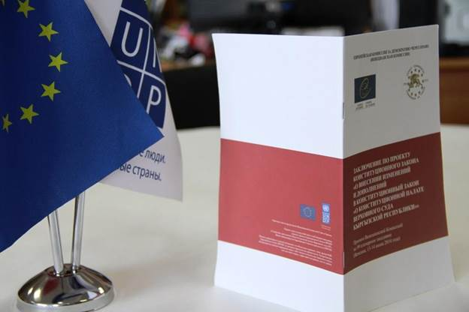

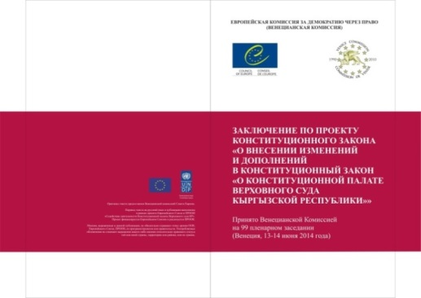

* After having received the Opinion, the Project held a discussion with the judges and staff of the CC on September 11-13, 2014. Participants of the discussion thoroughly reviewed the document, article by article, and the recommendations it contained. They agreed with the majority of recommendations produced by the VC and subsequently made relevant changes in the draft law. One of the main outcomes of the international expert analysis was that the judges of the CC refused rightly to explain their decisions. This amendment was inserted to the draft law in response to pressure tactics of several political institutions, such as those described earlier in this report where the CC it was inappropriately forced to revise verdicts.
* The relevant bill will be submitted to the Parliament in the near future. In December 2014, preliminary negotiations were conducted with the members of the *Parliament (Ms. N. Nikitenko and Mr. D. Terbishaliev, specifically)* concerning initiation of this draft law, and an agreement was reached that it will be submitted in January or February 2015. UNDP will follow the bill’s progress in the Parliament with expert observation, hearings, and media coverage.
* It is appropriate to mention that not all of the VC’s recommendations are reflected in the final text of the bill that will be sent to the Parliament, however. Considering current approaches in the Office of the President and the spectrum of political forces in the Parliament, the CC is not certain whether there will be sufficient support for the all of the positive recommendations of the VC. Moreover, there is a threat that the Parliament will make the law worse and limit the autonomy of the Chamber. Therefore, the CC has submitted an abridged version of the law to the Parliament, with a primary focus on the execution of decisions of the Chamber and a mechanism for its implementation.
* It is worth to mention that execution of chamber’s decisions is one of the problematic moments in its current activity. Its practice shows that only 10% of the decisions are really executed. Even if only this amendment were adopted, it would be a significant step toward the development of a modernized constitutional justice system. Remaining recommendations of the VC will not be ignored or entirely abandoned, to be sure; they remain relevant, but their further consideration must be postponed until there is a suitable political environment.
* In addition to working on the previously mentioned law concerning the Chamber, the Project assisted national authorities in obtaining VC expertise on another law related to the status of judges. UNDP helped in amending this bill by involving a local expert, translation it into English, receiving an official request from the Parliament, and submitting the text to the VC and OSCE/ODIHR. The expert opinion of the VC was presented, the bill finalized in view of its recommendations, and then tabled in the Jogorku Kenesh. This work was done in close collaboration with the OSCE Office in Bishkek. UNDP intends to follow the passage of this bill in the Parliament in 2015, similarly as the bill concerning the CC.

*Activity 1.2. Gaining support from main actors and stakeholders (the MPs of the Parliament, the President's Office, Government, Courts, CSOs, other decision-makers, and intelligent visionaries) by informing and providing them strategic advice on the roles, functions, and procedures of the CC; encouraging engagement of stakeholders in discussions about check and balances, power imbalances, and other important issues in the national context* *(workshops, roundtables, conferences, consultations, articles, presentations, etc.)*

As the CC has not yet become an appropriately strong institution, and operates in an unfavorable social and political environment, there is an urgent need to mobilize support from various influential actors to ensure stability in administration of constitutional justice. In view of that need, the Project made several efforts to attract actors to support the CC by making them aware of the role and functions of the Chamber and of appeal procedures, and popularization of successful international practices. With regard to civil society, the Project made inputs to raise its attention to issues of constitutional justice and to strengthen capacity-building of NGOs as real actors in order to become influential organizations in this field.

During the period under review, three large events and a series of small face-to-face meetings were conducted to achieve this objective. In addition, this task was mainstreamed in many other activities of the Project.

*Here are further details of the events conducted*:

In order to strengthen constitutionalism, as well as create favorable conditions for the CC’s work, in April 2014, the Project held a *roundtable titled “The rule of law or …political expediency?*”

Participants in the roundtable included prominent individuals, such as Mr. Omurbek Tekebaev[[1]](#footnote-1) who is known as the “father of the Constitution”, Mr. Daniar Narymbaev[[2]](#footnote-2), Mr. Emil Umetaliev[[3]](#footnote-3), and Mr. Nurbek Toktakunov[[4]](#footnote-4). Other participants in the roundtable were MPs Ms. Ainuru Altybaeva and Mr. Abdymanap Kutushev, as well as political analyst Mr.Tabyldy Akerov and Gulmira Mamatkerimova. Five of them were members of the Constitutional Council of 2010, affording the invited journalists and other participants the opportunity to receive valuable first-hand information.

This roundtable was particularly interesting considering that the keynote presenters invited by the Project had not the academic, but practical experience; they often faced situations in their own experiences where they had to make a choice between legal and politically easy ways of solving problems *(i.e. between the rule of law and political expediency)*. They were at the very center of constitutional processes with the drafters and implementers of the Constitution. They were quite aware of difficult and controversial environment that existed during the process of its writing, of how consensus was ultimately reached, and what proposals were made by whom and why. Therefore, the reflection on the Constitution “post-2010” was indeed fascinating and informative. The participants stressed that this event was the first one of its kind in the past four years.

Of particular interest was a portion of the discussion dedicated to the implementation of the Constitution and its provisions in a new environment that did not exist previously *(i.e. within the framework of parliamentary democracy, new principles of parliamentary operation, the conditions of a real system of separation of powers, actual political competition, accountability of the Government, and the experience creating a coalition Government and its performance).*

The participants analyzed the attempts to re-distribute power competencies in violation of the provisions of the Constitution. This is a highly topical issue in the national context. Daily implementation thereof by the Parliament, the President, the Government, and courts creates significant difficulties. In practice, the provisions of the Constitution are not fully enforced and adopted laws and decision, in some cases, contradict the Constitution. The largest problem is that the Presidency and Parliament still cannot preserve the balance of powers obliged by the Constitution; they continually compete for the power, pull it from each other, and intervene in each other’s own functions. All too often, illegal actions of those in power are justified by political expediency, issues of security, and stability.

Nevertheless, the participants said that the system of checks and balances enshrined in the Constitution continues to be quite effective, despite regular but still failing attempts of various political groups to re-distribute the powers. The Constitution helped hold a proper balance of the power and did not permit any of the political forces the opportunity to usurp it. The Constitution is still a safeguard of stability and manages to counter authoritarianism. As the “father” of the Constitution Mr. Omurbek Tekebaev said, this Constitution is the first and only one which was not changed during in a five-year period. The previous Constitutions were not stable and were subject to revisions practically every two or three years. In fact, the Kyrgyz Republic once saw three changes to its constitution in just one four-month period back in 2006.

Participants from non-governmental organizations and Mr. Nurbek Toktakunov criticized the lack of compliance with the Constitution in the country, and urged the authorities to refrain from changes to the Constitution, to abide by its provisions for the sake of having a state based on the rule of law and ensuring political stability.

One of the important conclusions made by the participants was the following: during periods of conflicting interests between the branches of power, there is a marked decrease in the enforcement of the Constitution and other normative and legal acts, the majority of decisions being politically motivated, rather than based in law. In such situations, it is the role of the CC to ensure compliance with the constitutional provisions.

The roundtable took place on the platform of 24KG, a popular news outlet in the country, with participation of various other media organizations and journalists. The roundtable was attended by 30 journalists from leading TV channels, radio, newspapers, and information agencies. Their participation ensured that the discussion was brought to a broader audience around the country.

*Capacity Building of Actors*

In order to take advantage of the presence of invited international experts by the VC and UNDP and use their potential to maximum benefit, and to reach a larger interested audience in the Kyrgyz Republic, we developed a practice of creating additional platforms on constitutional justice not only with the Chamber, but also with various stakeholders who can have a voice or can participate in some important processes in the country devoted to the justice issues. Such public events arranged by the Project were helpful in providing additional subject knowledge and in raising the capacity of actors.

The following activities were implemented:

*Roundtable on Functions and Role of the CC*

* A roundtable with VC experts from Croatia, Moldova, and Romania on the *role and functions of the CCs* was held on March 14, 2014. The experts attending included the President of the Constitutional Court of Moldova Mr. A. Tenase, judge of Croatian Constitutional Court Mr. B. Slavich, and former President of the Constitutional court of Romania Mr. L. Mihai. The day before this event, they conducted a peer-to-peer session with the judges of the Chamber (more details follow below). They managed to explain many issues related to constitutionalism to local participants, which included politicians, civil servants, researchers, lawyers, and prominent NGO leaders (i.e. those who have the opportunity to communicate these ideas to the authorities).

The experts told of the development of Constitutional courts in their own countries, about the surrounding environment during their respective development process, and ways of finding appropriate solutions for particularly complicated political challenges. Drawing on these examples of their countries, the experts demonstrated that courts are the cornerstone for a constitutional democracy, in the same way the Parliament is the symbol of representative democracy: “The task of the Parliament is to adopt laws and the task of the executive is to enforce them, while the Constitutional Court is the guardian of the Constitution and protector of human rights,” they said.

The experts shared their experience implementing the rule of law, the ways of enforcing the principle of separation of powers, and ensuring equality, proportionality, legal certainty, and judicial independence. They also described how they worked to make wider society more aware of the concept of gender equality, the rights of minorities, freedom of belief, financing of political parties, and other topics. They quoted the practices of their respective courts in solving disputes among the state agencies, as well. As the constitutional courts of Croatia, Moldova, and Romania were steadily working to protect the provisions of their Constitutions and managing to defend their principles, they received public support and recognition among the society. The experts stressed that no compromise can be allowed when the adherence to the Constitution is at stake.

The presentations by international experts had the character of strategic consultations. According to one of the national participants, “Such discussions have been lacking in Kyrgyzstan. We very badly needed internal discussions on the role of the Constitutional Chamber, as this topic is rarely considered.” It should be noted that the platform provided by the Project was very informative and made a meaningful contribution toward raising awareness of the Constitution and CC among the citizens of the Kyrgyz Republic.

*Guest Lecture on Challenges of Implementation of the Constitution*

* The Project organized a public guest lecture on the challenges of implementing the Constitution, constitutional courts, and amicus curiae for parliamentarians, NGO leaders, legal experts, university lecturers, advocates, students of law departments, and donor organizations. The lecture was held on May 19, 2014 and had 48 participants, including the deputy speaker and members of the Parliament. The lecture was delivered by Mr. Vakhtang Khmaladze, Chair of the Georgian parliament’s committee on legal issues and international advisor to the Constitutional Council of the Kyrgyz Republic in 2010. In addition to his role as an MP, he also delivers lectures on constitutional law at the University of Georgia.

Mr. Khmaladze provided a very instructive overview of constitutional law as a branch of the jurisprudence and addressed difficulties in the development of democracy, existing models for balancing branches of power *(legislative, executive, and judicial),* as well as the separation of competencies within the executive branch. More specifically, he demonstrated the danger of having just one entity responsible for defense, security, and internal law and order. These authorities should be checked by those of other governmental structures, with sufficient balancing mechanisms formally established in law.

He also described the practice of other constitutional courts, mechanisms ensuring their independence, and certain issues which should be avoided in their activities. He stressed that constitutional courts should refrain from politics, and the necessity of authorities restraining themselves from encroaching on court functions. Further, he shared his own experience in the development of an independent constitutional court in Georgia, as well as amicus curiae practices. Using the example of Georgia and other countries, he demonstrated the serious consequences that come from ignoring the Constitution: he explained to the participants that violations of the Constitution in Georgia in early “90s resulted in a serious disruption of the balance of interests and in of civil and political confrontation, finally resulting in civil war”. To note, similar experiences were observed in the Kyrgyz Republic, which had two revolutions after various manipulations with the Constitution.

In general, the lecture by Mr. Khmaladze was impressive. He successfully managed to illustrate the concept of “constitutionalism in action”, which was highly motivating for the participants and attracted their attention to the activities of the CC.

*Activity 1.3. Providing support to expedite the selection process to fill vacant CC seats*

* During the reporting period, the Project conducted advocacy actions to accelerate the *selection process* to fill vacant CC seats and to appoint three additional members of the CC of the Kyrgyz Republic. At present, the CC is incomplete; only eight of a total of eleven seats are filled. Therefore, as explained earlier in this report, there is a greater threat of not having a quorum necessary for the conduct of business. If even just one judge becomes sick for example, or recues themselves *(i.e. announces self-recusal),* or is challenged, then the Chamber will not have sufficient remaining members to perform its operations. This renders the Chamber a very unstable institution, which in turn jeopardizes citizens’ rights.
* Initially, monitoring of the process of nominating members of the Council responsible for the selection of judges was arranged. An advocacy campaign to accelerate the nomination of the members of the Council for the selection of judges in the Parliament was conducted. Afterward in December 2014, the full composition of the Council was approved and it began with its activities. To date, it has reviewed institutional and organizational issues related to its performance, has conducted an orientation training to familiarize new members of the Council with the instruments of judge selection, and now is deciding upon the schedule of selecting judges to vacant positions, including the judges of the CC. It is expected that by end January 2015 the schedule will be approved and the selection process will begin[[5]](#footnote-5).
* To ensure transparency of the selection in the Council, two non-governmental organizations were engaged by the Project to organize monitoring of the selection process, specifically the Institute of Public Analysis and the Institute for Constitutional Policy. Such civic monitoring will facilitate the early detection of political pressure on the Council, making the process more open and accessible to citizens, which will, in turn, positively impact the quality of new judicial staff.
* The Project plans to draft a brief situational note that will guide stakeholders in the selection process and make quality recommendations, as well as serve as an analytical tool for advocacy actions.

*Activity 1.4. Conduct meetings at policy levels jointly with the experts of the Venice Commission*

In the course of implementation, the Project organized a number of meetings and events for decision-makers at the national level with the participation of experts from the VC. These events have already been mentioned in earlier sections of the report, yet this section hopes to draw particular attention to two such events here:

*International Conference on execution of decisions of the CC*

On May 21-23, 2014, the Kyrgyz Republic hosted an international conference titled *"Execution of decisions of constitutional courts as a guarantee for effective constitutional justice".* The conference was organized by the CС with assistance from the EU, the VC, and UNDP. The theme of the conference had been chosen by its organizers because of its relevance to current challenges faced in the Kyrgyz Republic.

* The main objective of the conference was to increase efficiency in the execution of decisions made by constitutional courts. This objective is highly relevant for many countries, including the Kyrgyz Republic with the formation of its new CC. In any democratic countries, constitutional courts are the guardians of the constitution and their existence indicates a degree of constitutional and legal development. The execution of their decisions determines the efficiency of judicial constitutional review, as well as the degree of completeness in the execution of constitutional principles.
* By conducting this conference, the EU, the VC, and UNDP contributed to increased awareness among decision-makers and active civil society on the role and functions of the CC in a new environment. The VC and UNDP were able to bring a group of outstanding and knowledgeable experts, who were recognized by the judges, the Kyrgyz decision-makers, NGOs, and other participants. Participants received methodological advice on the functions of the CC and on its role in the state; they also benefited from the opportunity to learn from the experiences of others outside the Kyrgyz Republic. Because of this conference, international knowledge was shared directly with target groups, including decision-makers in the Kyrgyz Parliament and the Presidency and other political and social actors. The CC and its judges, thanks to their leadership in the process, also improved their standing with public agencies represented and generated trust from anticipating NGOs and academia. The conference also brought out new ideas in the CC for its own further development. A series of “themes for a future debate” were defined.
* The conference was attended by representatives of the constitutional courts of Latvia, Turkey, Armenia, Moldova, Tajikistan, Azerbaijan, and Kazakhstan. The participants also included international organizations and experts in constitutional and international law from Germany, Finland, Georgia, Norway, and Slovenia, as well as experts from the VC and the European Court of Human Rights *(the so called “Constitutional Court” for the Constitutional Courts”).*

***Pictures 3-5. International conference on execution of decisions of the CC***



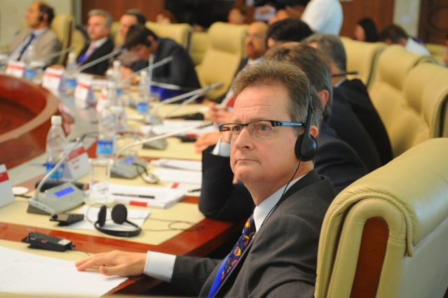

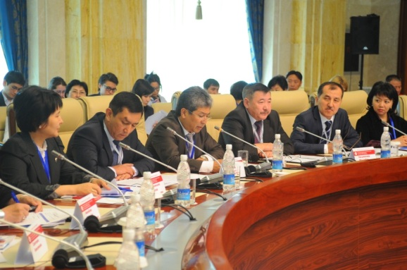

Important international event with key decision-makers and group of outstanding and knowledgeable international experts

* The Kyrgyz Republic was represented by its CC judges and staff, Supreme Court judges, civil society representatives, and major media. The conference was also attended by representatives of other governmental organizations and institutions which would especially benefit from the information, including the decision-makers from the Office of the President, MPs, and the Government, as their attitude toward the CC, in particular, has been seen at times as stymieing its effectiveness.
* In his opening speech, the Chairman of the CC Mr. Mukambet Kasymaliev reminded, "Execution of decisions made by constitutional review bodies is an important component in the protection of human and civil rights and freedoms, establishment of the rule of law, and enhanced confidence of citizens in the judicial system and the state."
* The conference was attended by EU AmbassadorMr. Cesare de Montis and Acting Resident Representative of the UNDP in the Kyrgyz Republic Mr. Pradeep Sharma, who jointly welcomed the participants. Their participation further helped to demonstrate the importance of the event.
* Mr. Cesare de Montis stressed that "successful implementation of the model for the execution of decisions made by the Constitutional Chamber, the degree of respect, and coherent execution of decisions made by the Chamber by state institutions and society will determine the effectiveness of constitutional justice,"

***Pictures 6-8. International conference on the execution of constitutional courts decisions – Opening statement by Mr. Cesare de Montis; Presentations by Mr. Gunars Kutris, the former President of the Constitutional Court of Latvia and Grigory Dikov, Lawyer of the European Court on Human Rights***

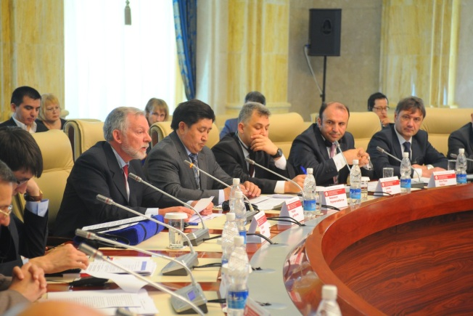

Mr. Cesare de Montis, the EU Ambassador

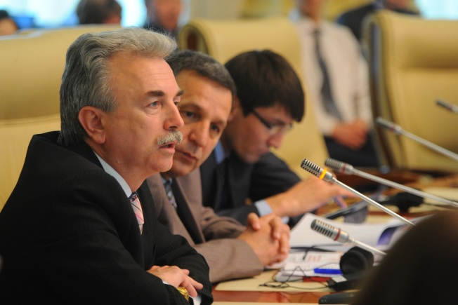

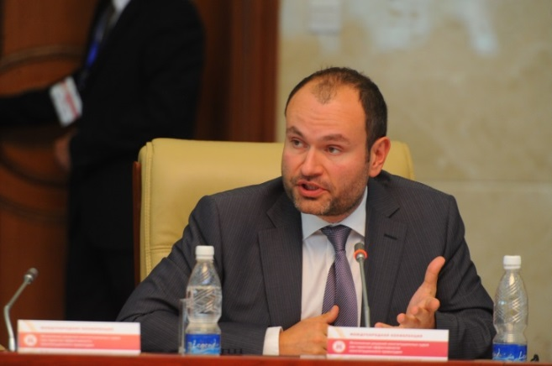

Mr. Gunars Kutris, the former President of the Constitutional Court of Latvia

Presentation by Mr Grigory Dikov, Lawyer of European Court of Human Rights

* The participants in the conference paid special attention to the quality of judicial decisions. Former President of the Constitutional Court of Latvia Mr. Gunars Kutris added, "I am convinced that the quality of execution of decisions of the Constitutional court largely depends on the Court itself and its professionalism. A court cannot create a problem by its own decision; its verdicts must be clear and authoritative."

One of the most thoroughly debated topics during the conference was the inappropriateness of revising decisions of constitutional courts. Mr. Kim Balayan, the judge of the Armenian constitutional court, stressed, "Revision of decisions made by a constitutional court is a bomb which will have to be neutralized by the entire society."

* Kyrgyz NGO leaders Mr. Nurbek Toktakunov and Ms. Cholpon Jakupova highlighted that the strength of the CC lies with the inviolability of its decisions and requested the representatives of the President, the Parliament, and the Government refrain from any pressure on the Chamber, even in the event that they do not agree to its decisions. The implementation of decisions of the CC also depends on the attitude of the society towards its acts. Greater confidence of civil society in the Chamber will lead to better execution of the Chamber’s responsibilities and to a reduction in politically expedient pressures placed on the Chamber.
* The conference resulted in the adoption of a resolution by the participants aimed at improving mechanisms for executing the decisions made by constitutional courts.

* The organizers of the conference from UNDP believe that the sharing of European and international experience, as this event allowed, will assist the Kyrgyz Republic in strengthening constitutional justice in the country, foster an environment that encourages further development, and facilitate the transfer of lessons-learned by other countries.

*Venice Commission Plenary Session*

With support from the Project in June 2014, a delegation from state agencies of the Kyrgyz Republic participated in the *Plenary session of the Venice Commission of the Council of Europe*. The members of the delegation included Mr. M. Kasymaliev, the Chairman of the CC, Mr. T. Tumanov, the Chairman of the Parliamentary committee on judicial reform, and two newly elected members of the Venice Commission. These two new members are Mr. O. Tekebaev, one of the more prominent members of the Parliament and principle proponent of judicial reform in the Kyrgyz Republic, and Mr. D. Narymbaev, who heads the Office of the President.

These high-ranking officials had the opportunity acquaint themselves with the opinions of the Commission on several laws which had been subject to expert analysis: the law on the CC and the law concerning the status of judges and electoral legislation. It is assumed that the participation of such officials in the event will facilitate the passage of these bills through the Jogorku Kenesh. Moreover, we hope that their attendance will, at least to an extent, also foster additional respect for the rule of law and constitutionalism in the Kyrgyz Republic. The EU and UNDP Project financed the participation of two delegation members, while the other participants were funded by the organizing Venice Commission.

*Activity 1.5. Providing support to ensure financial independence of the CC*

* In order to ensure the necessary financial independence of the CC, the Project assisted in the drafting of the institution’s first-ever programmatic budget. In 2014, the Kyrgyz Republic began efforts to have all of its state organizations utilizing a new budget format. Instead of using an old budget classification – one that had been in use since Soviet times – the government decided to switch to a form of programmatic budgeting that draws a clearer link between strategic objectives of the organization and relevant allocated resources, with precise indicators. Implementing this approach is a decisive step towards more goal-oriented financial management. Indeed, this approach was not just optional, but necessary, as the Kyrgyz Republic continues to be faced with limited revenues in its national budget and its ministries and agencies therefore regularly short of sufficient funding. The transfer to the programmatic budget methodology by government entities, including the CC, will make it easier to identify lower-cost and more efficient solutions to these financial problems.
* It should be noted, however, that this exercise was not an easy one for the Chamber, as it had no prior experience in drafting programmatic budgets. Financing of the Kyrgyz judicial agencies has also been a challenge for many years; typically, they are underfunded by the executive and the courts are unable to maintain their budgetary independence. Therefore, the EU and UNDP Project assisted in drafting a budget on the basis of these new approaches. Yet, as the budget of the Chamber is an integral part of a broader one that includes that for the Supreme Court, local courts, the Judicial Department, and the training center for judges, the Project needed to assist in developing a budget for the entire judicial system.
* To that end, a joint working group was established with the representation of all institutions listed above, as well as with representatives of the Ministry of finance. The EU and UNDP assisted in hiring two budgetary experts for the working group who helped to prepare the Judiciary Budget Draft, conducted workshops on programme budgeting, assisted the working group to identify strategic goals of the sector, and develop indicators. In addition, consultations on approaches that should be taken toward the implementation of budgetary reforms were arranged for the members of the working group. One hundred people from all judicial institutions responsible for the formulation of the judiciary’s budget benefited from the trainings.[[6]](#footnote-6)
* These activities spanned four months and resulted in the preparation of a draft of the first programmatic budget of the judicial system, to be used for 2015. The draft was then discussed at public budgetary hearings on August 6, 2014. During the hearings, Ms. Guldjan Esenalieva, chairperson of the financial commission of the Council of Judges, presented the draft judiciary budget and also highlighted the challenges presented by the consistent under-funding of courts. Her opinions were supported by members of the public and of the Parliament, which led to the Ministry of Finance proposing full funding of judicial institutions for 2015. Later, the draft budget was sent to the Parliament and subsequently approved. The budget of the judicial system for 2015 amounts to KGS 1.37 billion, 48% more than was allocated in 2014, and 0.9% of the entire national budget *(nearly double the previous year’s 0.48%)*.
* In 2015, the Project intends to continue such assistance by offering more trainings for the judicial institutions on budgeting and by supporting the process of formulating the budget for 2016. In the spring of 2015, the Parliament will hold hearings on the progress of the current 2015 budget for the judiciary, which, as noted earlier, includes that for the CC.
* The Project also plans to assist the Chamber in creating *internal audit mechanisms* to improve financial management practices.
* A series of events are planned to improve coordination between key figures of the judicial institutions *(i.e. those dealing with the judicial reform and staff of accounting units).* During the implementation of the Project so far, we have learned that these important entities have not always communicated effectively during the budget formulation process: accountants distribute available funds without taking into account strategic priorities of the system, while proponents of judiciary reform *(“reformers”)* often fail to show how their proposed reforms can be achieved with available funds. These issues cause serious implications for the entire reform process, with scarce funds being spent ineffectively and reform goals not being achieved. The Project intends to take specific actions to address these matters in 2015.
* It should be reminded that these forms of intervention by the Project provide a long-term benefit, and should be considered especially effective when taking into account the 100 officials that have been already trained in the aforementioned budget formulation principles. This activity directly contributes to greater autonomy of the judicial system, a goal which could not be achieved without the financial independence encouraged by these efforts.

*Activity 1.6. Assisting in creating a sustainable enabling environment through civic engagement, amicus curiae, civic monitoring, social surveys on implementation of courts decisions, etc*.

* During the reporting period, the Project initiated an important component of its planned activities: the establishment of an institute of *amicus curiae in the Kyrgyz Republic[[7]](#footnote-7).* At present, this institution is very necessary to the CC because it could help it to receive legal aid, spread juridical knowledge to the public, and create an enabling environment around the CC.

Nevertheless, the implementation of this Project component turned to be more difficult than initially hoped. The CC understood that it is not likely be able to rely on the full professional support of amicus curiae in the near future, and the process of developing such a tradition will take more time than originally planned. The Project also realized that when the project document was being developed, the capacity of civil organizations and scientific institutions in constitutionalism was overestimated. It has become clear that the Project would need to create this institute practically from the ground up*.* Initially, the Project intended to invite trained lawyers and representatives of scientific institutions to act as potential amicus curiae; however, we came to realize that the potential of the legal community to serve this function was weak and that we would not have the opportunity to take advantage of already available expert capacity.

* It had also become clear that we needed to be selective on who would actually serve as amicus curiae. Effective amicus curiae have *competence* in law and constitutionalism, excellent legal *reputation*, and a *meaningful platform* to voice any important messages or opinions to wider society. Unfortunately, there are few who have these qualities in the Kyrgyz Republic just now. Quality specialists, who no doubt are available, do not always have a positive reputation among everyone, and therefore neither the public nor the political establishment would likely heed their opinions. Conversely, those with strong reputations and loud voices often lack appropriate expertise. Many potential amicus curiae are often deprived of a meaningful public platform from which they can attract attention at the national level to their matters of expertise.
* After considering this situation further, the Project introduced amendments into the strategy for establishment amicus curiae. As the CC needs qualified support from the legal community and society now, the Project has produced several start-up scenarios of these work:
* a short-term scenario – to obtain available international amicus curiae/consultancies from the VC, constitutional courts, OSCE/ODIHR, the Max Plank Institution, UNDP, and others;
* help suitable institutions and legal professionals to learn best practices on amicus curiae with study visit/e-guest lectures, accelerating this process in the Kyrgyz Republic;
* conduct “quick tuning” trainings/workshops for existing suitable national intellectual resources and help them become operational; create several small precedents of local amicus curiae; connect various expert capacities and institutions which are currently separated and help them to elaborate working mechanisms. Small grant options will be considered if necessary;
* support activities of methodological council that the CC wants to establish;
* a long-term scenario aimed at forming an entirely new group of educated lawyers with the requisite expertise, voice, and reputation. This may not be possible within the Project’s stated duration,though the Project could lay the foundations for such an effort and create an operational mechanism.

*What has been achieved so far?*

* To implement the short-term scenarios described above, the Project helped potential amicus curiae in the Kyrgyz Republic to promptly obtain and explore relevant knowledge of amicus curiae, with a look at the experiences of the VC, Georgia, Latvia, Brazil, Spain, and other countries.
* For the judges and staff of the CC, three related events were organized:
* A *presentation for the judges of the Chamber on using the VC as amicus curiae* was delivered. More specifically, Mr. Schnutz Dürr from the Secretariat of the VC made a detailed presentation on amicus curiae, describing details of Commission’s operations and the procedures of appeal necessary to receive consultancy, which the CC can benefit from as well.
* *Experience of amicus curiae of Latvia* was learned by CC staff during the study visit to the Constitutional Court of Latvia. The Constitutional Court of Latvia agreed to help their Kyrgyz colleagues in studying the Latvian experience of amicus curiae and in establishing collaboration with them.
* Experience of the Centre of Political and Constitutional Studies of Madrid was learned by CC judges. This Centre serves as amicus curiae for the court system in Spain.
* All these experiences were thoroughly studied, explored, and adapted in view of their applicability to the national context, and the work resulted in the development of several operational mechanisms for amicus curiae in the Kyrgyz Republic. So far, we have *10 small cases* in which expert assistance by amicus curiae *(consultations of qualified scientists and lawyers)* were provided. The judges-rapporteurs of the Chamber obtained 10 professional opinions on issues of the criminal and civil law, freedom of faith, and religious organizations, on parliamentary proceedings and authorities, which helped judges in formulating their opinions and in producing their verdicts.
* One of the judges of the Chamber received assistance from an international expert advice on the issue of biometric data. The problem of collecting such data is of particular relevance in the Kyrgyz Republic, as the Government requires citizens to submit this information in the wake of forthcoming parliamentary elections. The expert’s input was submitted for the review of the Chamber, which is evaluating the policy as a potential violation of the constitutional right of citizens and their right to having personal details protected. Previously, such topics garnered little attention nationally, which in turn meant there were few professionals in the country with experience evaluating it. The opinion of the amicus curiae was therefore requested from an international specialist who in fact had that relevant knowledge.
* At present, the assistance that the Project has provided toward the implementation of an amicus curiae institute is yielding some positive results: it has effectively changed previously existing practices of closeness and secrecy surrounding the drafting of decisions, broadened the horizons of judges, and improved the quality of their decisions. Judges are also learning how to use amicus curiae as a resource, a resource that is becoming more and more popular, even after just one year of efforts to convince judges of the benefits of amicus curiae and to change their perceptions of the amicus curiae institution.
* Before its completion, the Project aims to introduce one or two amicus curiae operational mechanisms stemming from various fields of expertise, such as those representing scientific institutions, professional NGOs, or prominent practicing lawyers.

*What other events have been conducted within the frame of this direction?*

* On June 30, 2014, the Project supported the Association of Lawyers of the Kyrgyz Republic in conducting a *roundtable titled “the Role of the Constitution in the development of the national legislation*”. The Association of Lawyers is NGO working to unite members of the broader legal community, as well as other representatives of the legal field *(legal professionals, the Bar, judges, university professors of jurisprudence, as well as other NGOs)*. The organization members work in various areas: in courts, the Government, the Parliament, the CSO sector, and academia. The Association of Lawyers was created 20 years ago for the purpose of promoting legal profession standards, a cause to which it was expected to make important contributions. The Association brought all of its members to the roundtable. The event for Project was to a certain extent as a “probing” one which allowed for the evaluation of the capacity of the legal community and a look at the extent to which this community was capable of providing expert and analytical support to the CC by serving as amicus curiae *(see details above).* The roundtable was attended by the Judge-Secretary and the Head of the Administration of the Chamber, who attended in order to build relations with the lawyers.
* Regrettably, the speeches of the lawyers of the Association, its professors, and doctors of law demonstrated that at that time the Association was experiencing a certain “creative crisis”. They were not up to speed with the legal practices and events of the country or abroad, and its lawyers seemed to function in a more or less abstract environment of outdated concepts. Their knowledge of international legal standards and constitutionalism were insufficient, and they did not possess the tools necessary for conducting expert constitutional analysis. In this sense, their knowledge was behind that of practitioners, parliamentary politicians, judges of the Chamber, and even human rights activists, even though those actors are not professional lawyers.
* In view of those conditions, the roundtable had a serious discussion on the role and responsibility of the legal community. It was stated that lawyers in the Kyrgyz Republic were not fully involved in the reforms; they had “fallen out” of the process. Therefore, for 20 years, the Kyrgyz Republic had been pursuing legal and constitutional reforms with the efforts of politicians and “court lawyers”, but in the absence of legal professionals. It was stressed that the reformers, politicians, the Parliament, the President, and other actors could not wait longer until legal community would finally get involved. The same realization came to civil society and public defenders. Not waiting for the assistance or action from professional lawyers, NGOs began to meet this need society could not hold out longer for. NGOs began to study laws and conduct civil monitoring of legal and judiciary reforms, provide expert analysis on the implementation of the Constitution and laws, raise the standards and ethics of the legal profession, and respond to violations of the Constitution, acts of political pressure on the judiciary, and violence against defense lawyers.
* Despite the fact that the initial objective of the roundtable to mobilize qualified legal expert capacity for the support of the Chamber was not achieved *(as such quality expertise was, simply, missing),* the discussion was of great importance. It had a certain “shock effect” on the legal community and set the stage for re-evaluation. The Project hopes that this open and honest discussion will help energize and focus the legal community and the country’s lawyers, and that it would become a better partner of both the CC and other progressive forces in society.

*Civic Engagement*

* In addition to the amicus curiae, the Project focused on *increasing civil society’s interest in the issues of the Constitution, constitutionalism, and the CC.* To that end, the Project conducted a series of explanatory meetings with active NGOs, raising their awareness of the CC’s activities, its role, and its position in society. These meetings resulted in NGOs becoming more active in these areas and more acquainted with CC legislation, problems, etc. After these meetings, NGOs started to more frequently communicate with the Chairman and the judges of the CC, participated at CC’s sessions, and conducted their monitoring. Two NGOs, the public foundation “Precedent” and the legal clinic “Adilet”, conducted trainings for two target groups, NGOs and defense attorneys, centered on procedures of appeal to the CC. These were the first NGO-led trainings dealing with constitutional justice. Therefore, it can be stated that the Project helped to draw attention of NGOs to the activities of the CC, and demonstrated the importance of involving human rights NGOs in these sectors.
* Another event conducted by NGOs was an initiative to protect the Chamber, which was conducted as a roundtable and themed “The activity of the Constitutional Chamber: observation of the constitutional justice standards”. This roundtable was arranged by concerned civil society organizations and held in February 25, 2014. It was to a certain extent an “NGO’s fast response” following the January event in which the Parliament and the President pressured the CC into revising an initial decision. The NGOs and university lawyers discussed this case, made an assessment of it, and approached politicians with address on the inappropriateness of political pressure on the CC, as well as the on the need for strict compliance with the Constitution and a prohibition on the revision of CC decisions. NGOs called upon the CC judges to be strong, impartial, and able to withstand political influence. NGOs also expressed their opinions on the need to support the CC on behalf of civil society, monitor authorities in their enforcement of CC decisions, and generally keep a civic-minded eye on authorities in this important scope of public life.
* In October 2014, NGOs issued a second act of response to the situation with the judicial system and constitutionalism. They sent an appeal to the President stating the inappropriateness of changing the Constitution for the purpose of political expediency and urged him to keep it intact, at least until 2020 as the relevant provisions of the Constitution state.

*Activity 1.7. Assisting in communicating annual reviews to the Parliament, the office of the President, the Government, and civil society*

For the purpose of transparency of the CC and the analysis of constitutionality in the Kyrgyz Republic, the project assisted the CC in drafting its activity report from inception in July 2013 and until December 2014. The intended purpose of the report was to summarize the experience of the CC during the reporting period, analyze the status of constitutional law in the country and the execution of decisions, and communicate this information to the public, as well as to the institutions which should improve existing practices and take relevant measures. Work on the report is nearly complete. The Project provided assistance to this activity by contracting two experts. The document will be presented to the public in either January or February of 2015. This report will be the first of its kind and seed a practice of accountability to society and of transparency of the newly created Constitutional Chamber.

*Activity 1.8. Providing support to the establishment of a critical mass and awareness in the constitutional justice in the community of legal experts, which includes legal professionals, bars, judges, universities* *(conducting mini-workshops, problem discussions, and trainings, and creating a legal advisory board* *or specialized consultative and analytical center, as requested by the CC)*

See details under the Activity 1.6.[[8]](#footnote-8)

**R2. ASSIST WITH ESTABLISHING EFFECTIVE COMMUNICATION PROCESSES TO HIGHLIGHT IMPROVED CC PERFORMANCE AND RAISE PUBLIC PERCEPTION**

Within the reporting period, the Project assisted the CC in both improving the transparency of its actions, and in its interaction with NGOs, journalists, and other institutions. This is a highly necessary goal because, in the preceding period, the Court’s image and the public’s confidence in it were significantly undermined. The development of effective internal and external communications, openness and transparency of CC activities, the timely presentation of information to the public, accountability, a consecutive communication strategy, and capacity building of the press service are all expected to allow the CC to restore the trust of citizens, as well as make its performance more effective.

The following events were arranged within the framework of this component:

*Activity 2.1. Assisting with interaction between the CC and CSOs, Courts, other stakeholders, and establishing an inclusive dialogue platform for engagement of stakeholders to provide timely feedback to improve CC performance*

Two encouraging events were organized for two target groups: a *Summer School for Journalists* *(June 21-23, 2014)* and a *Summer School for NGOs (June 21-23, 2014).*

* The goal of the “Summer School for Journalists” was to raise journalists’ awareness of the CC, its role, and its functions, as well as to begin to creating a pool of court-focused journalists. Though there aren’t any in the country at present, the CC wishes there be such a pool of journalists who write specifically on judicial topics, and has taken advantage of the opportunities provided by this EU and UNDP Project that would help to establish one. A good group of journalists for the summer school was selected with the help from the editors at major newspapers, television stations, and information agencies.

The 30 journalists who attended received comprehensive information on important topics, including the specifics of constitutional proceedings, the CC’s structure and its activities, and rules concerning the media’s presence in the courtroom. They were acquainted with the CC’s website, and received contact information for CC officials and experts in constitutionalism whom they could contact for an interview or information. During the school’s practical session, the journalists practiced applying the knowledge they were given by writing detailed press releases on CC decisions. This was not an easy task for them, to be sure, considering the complexity of CC decisions and the specific terminology used in them. The CC judges who participated in this three-day training also had an opportunity to observe their own work from another perspective, at times noticing that the language they used was too difficult for the average person to understand. They realized that they needed to improve their structure and manner of drafting decisions so that they could be more effectively understood. The journalists demonstrated great interest and readiness for cooperation with the CC, and noted that they would prefer to cover its operations. They reported never expecting that the CC and its staff would be as open and cooperative with the media as they were.

***Pictures 9-10. Summer schools for Journalists and NGOs***

**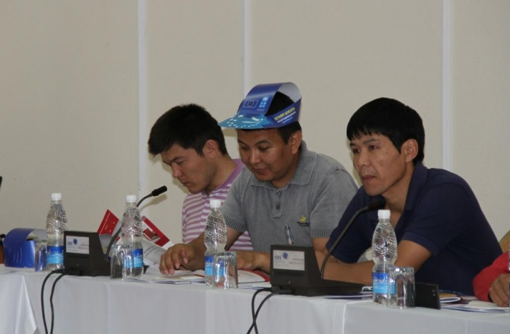**

**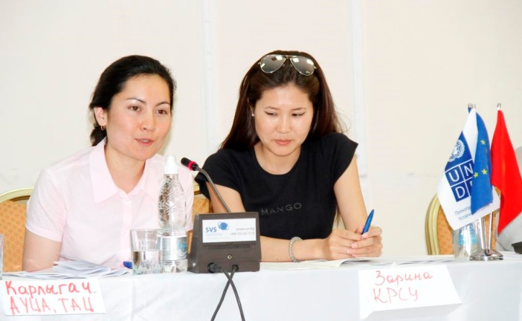**

* A second *“Summer School”, this one for NGOs*, was just as attractive and productive. It gathered interested civil society organizations with experience working with the courts, the Parliament, the President, the Government, and public entities, with CC judges and staff also taking part. The goal of this NGO summer school was to raise their awareness of the CC and to promote the aforementioned amicus curiae institution, both of which were achieved. During the practical session, NGOs practiced learning to read CC decisions and to “decode” them to understand and convey what they really mean for the public at large. Just as the practical session exercise was not easy for the journalists in their summer school, the NGOs’ practical exercise was also a challenge, and NGOs came to different interpretations of some CC decisions. CC staff who attended the school again concluded that there was a need to improve the quality of their decisions so that they are understandable for the wider society. In addition, NGOs tried to prepare drafts of appeals to the CC in order to practice utilizing what they had learned. During the event, one of the participating NGOs shared with others its experience in monitoring of the CC as well.
* Overall, these two summer schools turned out to be very useful. Both events began to improve on the demonstrated communication challenges between the CC, the media, and NGOs, acting as a bridge between them and encouraging further progress. The Project’s role in the process had many elements: in addition to providing logistical organization of both events, it worked to ensure quality content and presentations, strong participants, and regular interaction with the CC on organizational issues. During the training, Project specialists also provided a significant amount of information that allowed the participants to have a comprehensive picture and understanding of the matters they were there to study.
* In recognition of Constitution Day, the Project assisted the Chamber in conducting *an awareness campaign on the rule of law and respect of the Constitution.* A series of events were arranged as part of this campaign, which included the following:
* A roundtable titled *“The rule-of-law or …political expediency?”* should be mentioned first. This event was dedicated to discussing the Constitution, its implementation, and the status of the rule of law in the Kyrgyz Republic *(described earlier in Activity 1.2).*
* On May 8, 2014, the CC held an *Open Doors Day* for the students of the capital city’s universities in order to demonstrate the CC’s openness and transparency. The students visited the Chamber, learned about its activities, constitutional proceedings, and the difference between these proceedings from criminal and civil proceedings. The students had an interesting dialogue during the event in which they showed serious interest in constitutional proceedings, and asked reasonable questions that likely many in the public would be interested in knowing *(such as why two judges have not been selected to the CC to complete the selection process, how the judges handled political pressure, how one could become a judge of the CC, etc.)* The CC staff also informed the students of its website and how to use it to find information such as court hearing schedules and adopted decisions. This event was covered widely in the media and received positive feedback. Students received a memorable photo with the President of the court.
* A number of television products were produced and broadcast on national television channels. Specifically, a *20-minute documentary film was made to advertise the work of the CC*, and was shown on OTRK, the major national TV channel.
* A *TV video reel on the supremacy of the Constitution* and its role in the protection of human rights was produced, as well. In it, five popular young singers composed and then sang a song dedicated to the Constitution in the Kyrgyz and Russian languages. This video was shown on many TV channels, as well as uploaded to social networks. News agencies also covered this video and the process of its creation. This was another successful effort to attract the attention of the public to the rule of law, constitutional rights, Constitution, and its implementation.
* Constitution Day was also marked by *brief television messages by politicians,* civil servants, human rights activists, and notable public figures speaking about the Constitution and its role in stability and the life of the country. These messages were broadcast over the course of one week on various TV channels, with the aim of raising awareness and appreciation of the legal system and respect for the rule of law. This particular informational campaign provided coverage available to 97% of the country’s population.
* In addition, the Project helped conduct a *meeting with the editors in chief and journalists of major media outlets*. On June 17, 2014, a meeting with the participation of judges, editors, and prominent journalists was held. The judges briefed the editors about the Chamber, their own activities, and their intention to create a pool of journalists to provide regular and objective information to the public on CC activities. The meeting was marked by interesting dialogue. The CC website was presented during the event and an agreement was reached on mutual cooperation, communication channels, and the need to increase the skills of journalists covering the work of the courts.

*Activity 2.2. Providing support to the development and implementation of the communication/outreach strategy and plan; conducting workshops for relevant staff and judges to implement this*

* The Project assisted the judges and staff of the CC in building on its communication strategy. Supposed that this strategy, if adopted, will serve as an important tool for ensuring transparency and openness of the CC. Work on the development of the strategy was divided into two stages: the study of appropriate best practices on the subject and the actual development of the strategy.
* At the first stage, the experience of developing constitutional court communication strategies in Georgia, Ukraine, and Romania was explored. As was mentioned in inception report *(2013)*, on December 11 and 12, 2013, the Project jointly with the VC conducted a workshop for the judges of the CC on the *development of public relations (communication) strategy*. The VC invited practicing media experts as lecturers, as well as staff of press services from the constitutional courts of these countries *(among the guests were the Head of Administration of the CC, a staff member of the press service, and a journalist from "Internews").*
* A practical, interactive approach used during the workshop made for a very interesting and useful event. The judges received a lot of information on the importance of explaining decisions of the court to the public, communicating with wider society, and making sure that the decisions of the Court are fair, well-justified, and professional. The trainers helped the judges to define their readiness to properly engage with the public, as well as to find the appropriate balance between openness and privacy. The judges realized that the Chamber performing its duties in secret will result in a negative image of the institution and decrease the confidence citizens have in the decisions it makes.
* The workshop allowed the judges of the Chamber to acquire knowledge of various international practices used for dealing with the public and different target groups *(the media, journalists, state agencies, internet users, and legal professionals, for example).* Two-day training resulted in establishment of a shared vision among the judges for having a prioritized plan of the actions needed in order to develop communicative skills draft an institutional communication strategy and rules for external communications, and implement the use of various informational and media mechanisms in their work *(such as official publications, internet sites, press releases, press conferences and briefings, briefings roundtables, etc.).* The participants from the Kyrgyz CC were motivated to develop a communication strategy and a communication plan, as well as to create a CC press service in order to restore the confidence of citizens in their work *(see Pictures 11-14).* In the end, the Chamber created a working group headed by the Secretary Judge Ms. Chinara Aidarbekova and Press Officer Ms. Nazgul Nurbekova. This Working Group was tasked to develop a communication strategy of the CC.
* At the second stage on the request of this Working group EU and UNDP assisted the CC judges and staff in elaboration of the strategy. A two-day workshop was conducted for the staff of the Chamber to actually draft their communication strategy *(April 17-18, 2014)*. During the event, the participants did practical work on determining the strategic and communication goals of their own organization. Their work resulted in having a draft communication strategy and a plan for its implementation. The training was conducted by the local media organization “Door Media” in both the Kyrgyz and Russian languages. The training was attended by 70% of all CC staff members, including the Secretary Judge and two CC judges, as well as the Head of Administration of the CC.
* In July 2014, a first draft media strategy and plan were presented to all judges and staff of the Chamber for their comments. It is no currently being refined and will, once finalized, become part of the overall development strategy of the CC. This unified strategy is expected to be formally approved in the spring of 2015, and we believe that it will significantly improve the communications of the Chamber, its openness, and its transparency.

***Pictures 11-14. Workshop on public relations***

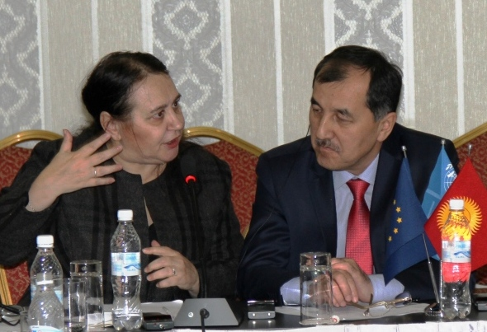

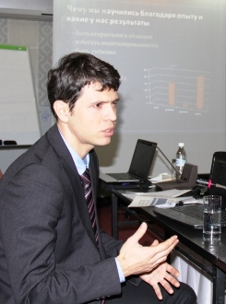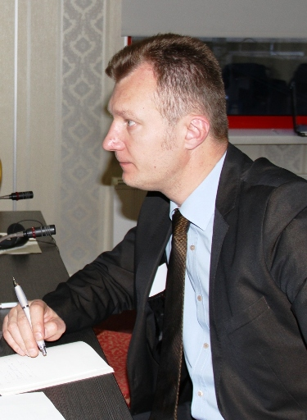

Experts from the Venice Commission, Ukraine, Georgia and Romania sharing their best practices with the Kyrgyz CC judges on establishment of effective communications between constitutional courts and society

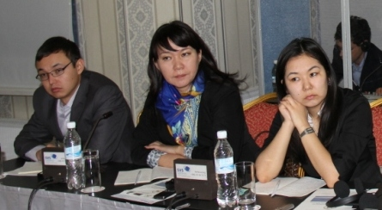

*Activity 2.3. Enhance the capacity of the press service and provide continuous TA following up the media trainings for the judges of the CC conducted by the Venice Commission*

A number of trainings were conducted to strengthen the capacity of the Chamber to understand and communicate effectively with the media:

* On November 11 and 12, 2014, a training for the judges and the staff of the CC was held on the subject *“Understanding of media and ability of judges to communicate with them”*, which saw 22 people in attendance. The trainer for the event was British TV newsmaker, media consultant, and videographer Mr. Jim Gibbons. Mr. Gibbons has over the last 40 years widely reported on European affairs for television, radio, and print media, and been the recipient of distinguished awards in journalism, including five awards from CNN. Mr. Gibbons has had the opportunity to host television debates and news programs for such international channels as Euronews and Deutsche Welle. In addition, he has produced training and informational videos for the City of London, the European Central Bank, the Council of Europe, and the European Court on Human Rights, serves as a moderator during international conferences, and provides training to journalists and those who work with the media.
* During the one-day training, Mr. Gibbons talked to the participants about various journalism-related topics, including relations between the media, politicians, and judges, specific factors that should be taken into account when working with politicians and judges, and features of TV, radio, and print journalism. He also shared some professional techniques on how to address unwanted questions and handle difficulties that can emerge dealing with the media. In addition, he conducted practical exercises with the judges and staff of the Chamber, arranged live video stand-ups, and radio interviews. Finally, he gave practical recommendations to each participant on how to improve his / her own communications with journalists, and how best to perform in front of a camera.

***Picture 15.*** [***Assistance to the Constitutional Chamber of the Kyrgyz Republic***](http://www.venice.coe.int/webforms/events/?id=1933)

<http://www.venice.coe.int/webforms/events/?id=1933>

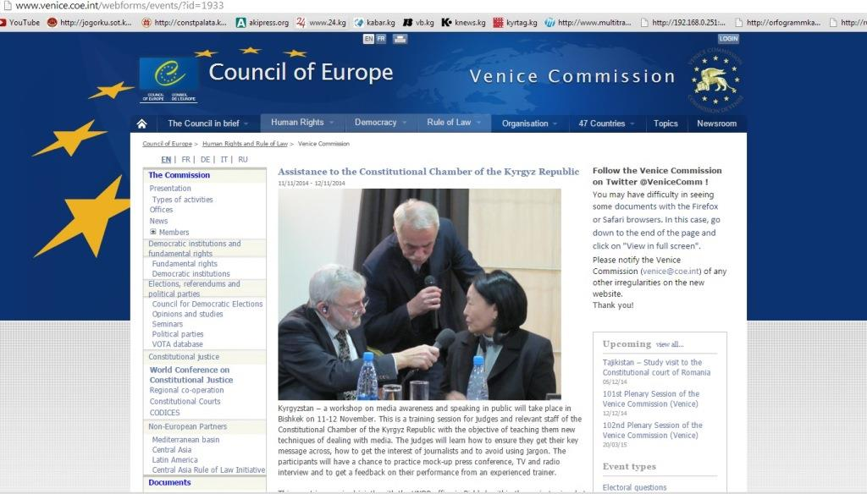

* Once this portion of the training had finished, Mr. Jim Gibbons provided recommendations on further actions the Chamber and the Project could take to supplement and build on the knowledge he provided them. For example, he recommended the Project continue working with the judges to help ensure the skills of communicating with the media are internalized and the application of techniques more automatic. Accordingly, the EU and UNDP Project intends to conduct a series of stand-ups with the judges and the Press Officer.
* On the day before this training *(November 10, 2014)*, Mr. Gibbons had a *meeting with local journalists.* This meeting was arranged by the Project to gain insight from journalists on local media content, as well as some on the problems they have getting information from the Chamber’s press service. The knowledge obtained helped the international expert to better understand the context of work of the CC and to provide the judges with relevant recommendations for their work. This meeting with journalists was mutually beneficial, as the local media specialists received good advice from an experienced foreign reporter.
* As part of the study visit to the Council of Europe organized jointly by the VC and UNDP, the judges of the CC had the opportunity to become acquainted with the work of *the press service of the European Court of Human Rights (ECHR).* They met Ms. Nina Salomon, the press attaché of the Court; she explained the operation of the Court’s press service, described the cooperation between the court and the media, and noted this court’s more restrained approach giving answers to the press. She also discussed how the press service conducts media and image campaigns, as other institutions similarly do. The ECHR mostly works with the media indirectly, offering the society ready information and reports, for example by ensuring access to a comprehensive electronic database of decisions through its website. Recently, the ECHR started to conduct trainings for journalists, bloggers, and human rights activists, as well as organize visits for them to the sittings of the Court. Of particular effect are trainings for journalists from the country whose case is being reviewed in the Court. In such cases, the press service of the ECHR invites such journalists two days before the sitting, conducts trainings with them on the operation of the Court, and then invites them to the session where the case from their respective country is reviewed. These trainings help the journalists to better understand the work of the Court and the particular matters of the case under review. The journalists who attend become more aware of how their country appears from an international prospective and provides substantive, unbiased coverage of the ECHR’s decisions. The judges of the Chamber were very much impressed by the experience of the ECHR shared, and stated that they intended to use some of the practices and tools described in their daily work. The particularly enjoyed a video on the procedures of appeal to the Court and electronic forms of appeal. In 2015, the Project intends to help implement some of these ideas in the institution.
* On March 1, 2014, the staff of the Secretariat of the Chamber underwent training on *effective press release writing.* The training was conducted at the request of judge-secretary Ms. Chinara Aidarbekova for 11 CC staff members responsible for drafting and posting press releases on decisions taken by the CC. The trainer was Ms. Gulnura Toralieva, Press Secretary of the Prime Minister of the Kyrgyz Republic. The participants received practical skills on how to process information necessary for producing press releases. Special attention was given to text style and the replacement of the legal terms and complex sentences with language more understandable by common readers. Following the training, the contents and accessibility of the press releases posted on the CC’s website improved significantly, and were more often viewed by information agencies.
* As a follow-up, the Project will do the following in 2015:
* Conduct stand-ups for judges;
* Continue working on the creation of a pool of journalists and columnists who have a strong knowledge of the activity and roles of the CC, so that information is properly and accurately communicated for to public;
* The Project also envisages outreach programs for CSOs, the media, universities, and other institutions that can appeal to the CC.

*Activity 2.4. Improve CC’s reporting requirements and standards*

The Chamber is still just being formed, but aims to become a fully modern, professional, transparent, and efficient organization that follows national and international standards and the expectations of the society it serves. In accomplishing that aim, the CC intends to establish a system of internal and external statistical reporting, performed monthly, semi-annual, and annually, which will allow society to track the performance of its activities and observe the dynamics of its development, and for the CC to show the results of its work to society and promptly respond to the challenges of its development.

At the request of the Chamber, the UNDP and EU assisted in the development of this reporting system. To achieve its objective, a contract with the National Statistical Committee was concluded. This work is currently underway and will be completed in 2015.

*Activity 2.5. Ensuring transparency and efficiency of the CC through the usage of ICT applications, their design, and a pilot website*

This activity has been completed. For more details, see the inception project report, submitted in January 2014.

*Activity 2.6. Support easy-to-read publications, leaflets, and infographics for the public*

During the reporting period, the Project assisted the CC in preparing and producing the following publications:

* A first-ever profile of the Chamber was prepared and published. The profile is used by the CC in its contacts, and disseminated at all public activities in which the CC participates;
* The first ‘Bulletin of the Chamber’ that includes all of its decisions was printed, as well. In accordance with relevant law, the CC must make all its decisions publicly available. The Bulletin *(made available in two languages)* in total amount of 850 copies that were disseminated to all 450 judges in the Kyrgyz Republic, the Government, the Parliament *(120 Members of the Parliament),* and to various legal organizations.
* The Bulletin also contained the materials of two conferences conducted by the Chamber within the framework of the Project.
* It should be noted that most of the materials of the Project’s public events in which the CC participated *(including workshops, conferences, trainings, etc.)* were collected/ taped/ reproduced, and serve as an institutional memory of the organization. They will be published in easy-to-read publications and booklets and made available to the general public. Thus, the EU and UNDP Project is helping to preserve useful information pertaining to constitutional justice so that it can be disseminated, popularized, and made useable for decision-making and educational efforts.
* The plan of publications for 2015 was discussed with the Chamber, which specifies that some publications will enjoy support from the EU and UNDP. This plan contains many ideas taken from the various constitutional courts visited by the judges of the CC; the Project will help to implement them in 2015.

*Activity 2.7. Conduct baseline and follow-up surveys*

After its re-establishment in 2013, the CC has been striving to build a new, more efficient organization that meets national and international standards of constitutional justice. It seeks to increase its own efficiency, professionalism, transparency, and independence, as well as to raise the awareness of the public about its role and functions and to improve its communication with society.

To measure the effectiveness of its work and the attitude of the public, the CC is conducting an independent sociological *Baseline and Perception Survey* and will, from its results, study society’s opinion about its activities, the status of constitutional justice, the level of knowledge of the CC, and the trust in it to understand and take into account the views of the public in its work. In connection with that, the EU and UNDP Project, after soliciting proposals, selected an independent public opinion polling organization to conduct this survey *(the selected organization is El-Pikir Public Opinion Centre).*

This research is still underway. It will be the first survey in the Kyrgyz Republic specifically considering the operation of the Chamber. Indeed, this research effort could be groundbreaking if it yields good data and allows for high quality analyses. It is assumed that the survey will serve as a starting point for further comparative analyses, and for identifying any trends or changes in the public’s attitude and knowledge of the CC over time. It will also lay the groundwork necessary for any follow-up survey.

More detailed information on this activity will be provided as soon as survey results are available.

**R3. ASSIST WITH INSTITUTIONAL AND INDIVIDUAL CAPACITY-BUILDING THAT HELPS THE CC IN ACCOMPLISHING ITS MISSION**

The importance of this component is beyond doubt. The effectiveness of the institution depends on the availability of competent and fully qualified judges and staff, professional management, strong leadership, and the availability of a stepwise strategic plan the actors have ownership in. Without competent and fully qualified judges and staff, the Chamber will not function at an optimal level or be able fulfill its responsibilities. Since the CC lacks sufficient capacity, necessary skills and technical resources to work in a new environment, and to manage the scope and volume of its essential tasks ahead, must be created.

In order to help the CC in improving on its deficiencies, the EU and UNDP on its request designed relevant events which foster quick solutions to these problems, so long as the beneficiary organization is invested in the process and outcomes. The details of these events are provided below.

*Activity 3.1. Conduct initial orientation training programme for judges and staff (with involvement of the VC experts)*

* The Project contributed to conduct of an *orientation workshop for the judges and staff* of the Chamber. In the world of talent management, new employee orientation is known as “employee onboarding”. It effectively integrates the new employee into the organization and assists with retention, motivation, job satisfaction, and quickly enabling each individual to become contributing members of the work team. One rarely has a second chance to make a good start to an organization they’re joining, so it is of course very important to perform it well.
* In view of this, the Project made a proposal to the CC and the VC to arrange an orientation workshop; it was fully supported and all stakeholders worked to prepare for the event. The CC ensured the involvement of all participants, while the VC guaranteed the attendance of international experts and deployed Mr. Sergei Kuznetsov, the head of the VC department. UNDP provided a platform for joint work in the ground and actively participated in the drafting of the agenda and design of the platform and ensured the presence of national experts in the workshop.
* As a result of preparatory work, a two-day orientation workshop for the judges and staff of the Chamber was conducted in November 2013. Three international experts from the constitutional courts of Latvia, Slovenia, and Ukraine shared their experience and practice with their Kyrgyz counterparts at the event. Eight judges of the Kyrgyz CC and its staff actively participated in the workshop, exchanging their views with the experts from the VC, and discussing problematic issues and business operations of the Chamber and its organization. Possible solutions and approaches were jointly considered, as well. The event was a platform useful for the judges to promptly receive high-quality strategic consultation and information on issues of their interest by the VC experts. Feedback from national experts participating in the workshop was also of use.
* These actions from the EU, the VC, and UNDP were important for the quick operationalization of the CC in the Kyrgyz Republic, especially in view of country’s politically volatile situation. The orientation helped to get the organization off to a good start, to add efficiency to its operations, and to accelerate its overall performance, while also helping judges and staff to better understand their functions and roles.

***Pictures 16-19. Orientation seminar for the judges and staff of the CC of the Kyrgyz Republic***

|  |  |
| --- | --- |
|  | |
|  |  |
|  |  |

* The high motivation of the Kyrgyz judges, including the Chairman, shown in these events is laudable – they never missed a portion of the training sessions, were active in asking questions, and fully participated in its debates. They shared information about the Chamber, its status, and its current business, as well. Truly, such motivation on behalf of beneficiaries, especially those in the public sector, is rarely seen. We hope that this attitude and interest in trainings, and the expert knowledge imparted, will remain in place until the completion of the Project. We also believe that this approach taken towards capacity building will definitely ensure the sustainability of inputs, as well as success in establishment of a professional and competent institution able to perform the duties they are entrusted with. Such interventions are, of course, always dependent on the attitude of the beneficiaries and their motivation to learn and to develop the institution they serve in.

* During the workshop, the participants highlighted the need for having an institutional strategy for the Chamber as a tool for making it a more effective and successful agency. A working group chaired by one of the judges was established to draft the CC development strategy *(see more information on this topic under Activity 3.2).*

*Activity 3.2. Providing support in the development of an organizational development strategy which is discussed with stakeholders and presented to the public*

As mentioned above, the Chamber is undertaking efforts to refashion its organizational structure and transform itself into a new, modern institution that follows national and international standards of constitutional justice, as well as being one that meets the expectations of a society which desires to have a professional, competent, and efficient CC that is independent, transparent, and effective. In view of the lessons learned from its history, the leadership of the CC intends to raise the effectiveness of its organization, bring a more strategic vision to its operations, and minimize unpredictability in its work. In this regard, the CC plans *to develop a mid-term strategy* for its own institutional development.

*The following results have been achieved so far:*

* In September 2014, a two-day *retreat of the Chamber* was held, which was dedicated to institutional development issues, as well as the ways to help to make the management of the institution and its further growth more strategic and effective. This event was attended by the Chairman, Deputy Chairman, all of the judges, the Head of Administration, and five key staff members, with a total of 14 participants. They discussed many important issues pertaining to the current and strategic development of the CC, including capacity building, communications, business processes, the draft law on the Chamber, and strategic planning. The findings of a survey on the training needs of the CC were also presented.

* During the retreat, an analysis on strategic planning in the Chamber was presented. It was stated that the attitude towards strategic development of the institution during the previous years was not satisfactory, and therefore its development was uncalculated, causing confusion, redundancy, and inefficiency. It failed to perform its mission to protect human rights and the Constitution, and was unable to create trustworthy protections against authoritarianism or the usurpation of power.
* Based on the outcomes of the discussion, the members in the retreat made a policy decision on drafting a strategy. *A working group was created* and headed by one of the judges made responsible for forwarded the strategy development process. The EU and UNDP hired excellent experts – Mr. Michail Munkin and Ms. Alena Bevzova from Interactive Company – who had relevant experience and qualifications to facilitate this work. With this assistance, development of the strategy went from a conceptual goal to a fully realized one – that is, from just ideas and words, to impactful action.
* On October 14, 2014, *an introductory workshop was conducted with the judges and staff of the Chamber* aimed at making progress on the development strategy. During the workshop, the participants were made aware of the strategic planning tools necessary for the drafting of the development strategy, and, in the end, a step-by-step plan was produced for the working group;
* On December 8-9, 2014, a two-day workshop was conducted to sketch a rough *draft of the strategy.* The participants made an overview of the development strategies of other constitutional courts, conducted a ‘SWOT analysis’, and collected information necessary for their work. The workshop included sessions on the description of the vision, mission, goals, and objectives of the strategy and the communication strategy of the Chamber. A tentative plan for the implementation of the strategy was also discussed with the intention of including monitoring and evaluation mechanisms. The workshop resulted in draft versions of the “mission”, “strategic goals”, and necessary steps, as well as an intended action plan for the future strategy. The workshop was attended by 21 people, including five judges, the Head of Administration, and heads of key CC departments.
* *A participatory approach* was ensured by the Project during the entire strategy development process, and periodic reconciliation of each stage of the development of the strategy was conducted. Because of this participatory approach, in the end of the process the CC will obtain skills needed to plan institutional reforms and will received several “strategically-minded individuals” *(so called “strategists”)*, which should be in each organization.
* This activity will be continued in 2015. The draft strategy will be supplemented by more details and specifics, and a gender and human rights expert analysis will be conducted. There are plans to include gender and human rights dimensions in the main text of the strategy.
* In February and March of 2015, the final version of the strategy will be completed. It should be noted that this will be the first development strategy of this institution in the Kyrgyz Republic.

*Activity 3.3. Conducting tailored trainings and individual coaching for judges, staff, and the different units of the CC, which includes aspects concerning human rights, gender sensitization, minority representation, international agreements and conventions, conflict sensitivity, leadership, management, ICT, language, and team-building*

During the period of Project implementation, 14 different training events were conducted, five of which were attended by representatives of the VC and its experts.

Workshops with international experts and support from VC*:*

* On March 13, a one-day *workshop on constitutional review* was held for the CC judges*.* Constitutional oversight is an important function of the Chamber but unfortunately continues to be quite weak in the Kyrgyz Republic. The judges and staff do not yet have sufficient skills to conduct high level constitutional expert analysis. Therefore, for two days, the visiting experts in constitutional justice shared their experience and knowledge with the judges and staff of the CC on how they conduct constitutional review in their respective home countries. The experts came from Croatia, Moldova, and Romania, and included the President of the Moldovan Constitutional Court Mr. Alexandru Tanase, former President of the Constitutional Court of Moldova Mr. Lucian Mihai, a judge of the Constitutional Court of Croatia Ms. Slavica Banic,and the Secretary General of the Constitutional Court of the Republic of Moldova Ms. Rodica Secrieru. The workshop was of much interest to the target groups, who had the opportunity to hear first-hand details of the professional work performed by the visiting experts.
* On March 14, the same international experts conducted a workshop for CC staff *on the internal organization of work of a constitutional court.* In this event, the invited guests paid greater attention to the work of the administration of constitutional courts. This was also highly informative, as many of the experts were previously administrative staff of their courts themselves. For example, before becoming the President of the court in Moldova, Mr. Lucian Mihai was its Secretary General and Ms. Slavica Banic was the advisor of the Croatian Constitutional Court before becoming a judge herself.With this background, they know well the work of the staff and how it should be organized. Their professional career served as an example and demonstrated how the staff of the CC could also work. Informative presentations were also made by Mr. Alexandru Tanase, President of the Constitutional Court of Moldova who, from his authority, was responsible for functions involving staff in his institution and accordingly brings first-hand experience with human resource management highly relevant to the event’s attendees. Another interesting presentation was made by the head of the Administration of the Moldovan Constitutional Court, Ms.Rodica Secrieru. In her presentation, she described the role of court staff in assisting the court’s performance, and answered questions on functions and interaction between various units in the administration of the Court.

|  |  |
| --- | --- |
|  |  |
| Описание: Описание: \\File-server\eu-undp\project_docs\2014\Фотоотбор_для_Дня_Европы\сжатая\SAG_2605.jpg | Описание: Описание: \\File-server\eu-undp\project_docs\2014\Фотоотбор_для_Дня_Европы\сжатая\DSC_0739.JPG |
| ***Picture 20. Ms.Slavica Banic, Constitutional Court of Croatia: "The Court has assumed a key role in building democracy" (13.03.2014)*** | ***Picture 21. Mr. Alexandru Tanase, Chairperson of the Constitutional Court of Moldova (13.03.2014)*** |

* On May 19, 2014, a *workshop on writing court decisions* was held jointly with the VC*.* The aim of this event was to strengthen domestic expertise in the court and the quality of decisions it makes. The workshop was dedicated to overcoming the difficulties in work related to the use of analytical sources, specifics of preparing and writing judgment rationale, and the proper style, format, and structure of the document. The experiences of the constitutional courts of Croatia, Moldova, Romania, Estonia, Slovenia, and Poland served as case studies. Experiences in preparing and drafting of decisions of European Court of Human Rights and opinions of the VC were studied as well.

The Head of the Judiciary Department of the VC Mr. Schnutz Dürr informed the CC judges and staff on the *database CODICES*, which was created by the VC in order to facilitate the work of constitutional courts worldwide. This database keeps decisions of the world’s courts on various topics; therefore, it is an important tool for the work of all similar institutions, including the Kyrgyz CC. It allows judges and staff to identify relevant practices in other countries, and then learn from and apply them in their work if necessary. That this practice is also followed in other countries helps to demonstrate the database’s relevance; information found in it has reinforced the arguments made in judgments, brought countries’ court decisions closer to international standards, and allowed for the synchronization of court practices.

The chief lawyer of the Secretariat of the ECHR Mr. Grigory Dikov used *example verdicts of the European Court* in order to demonstrate to the judges of the CC how the acts are written and how they are interpreted. He presented a typical structure of one of the court’s decisions, on the interpretation of facts, and on assessment criteria in the deliberation. He also introduced the concept of subsidiarity and how it is manifested. Further, he highlighted criteria necessary for the legitimacy of decisions in the eyes of the Government, the professional community, and the public, which include stringent analysis and refraining from momentary decisions.

* A “closed door” meeting was held with Mr. Vakhtang Khmaladze and the СС judges on May 20, 2014 to discuss the *constitutional reform process in 2010, constitutional design, constitutional balance in Kyrgyzstan, constitutional arrangements* of the judiciary, and its independence and leverage in the execution of judgments. This meeting provoked great interest. Unfortunately, because the CC judges lack institutional memory of constitutional discussions, which took place during the constitutional reform efforts back in 2010, understanding of the constitutional concept and design are challenging. Similarly, the CC judges and staff have deficiencies in their understanding of the democratic governance system, the principle of checks and balances, and of parliamentary democracy in general. This certainly creates risks and a possibility for pressure on the CC not only from politicians, but also from wider society. Therefore, the CC should, within a short period of time, learn these important principles and systems *(to restore this knowledge);* it should create a mechanism that will allow it to obtain background information about the original constitutional drafting process and the thinking of those who helped write it, as such knowledge will help the judges to better ensure those original intentions are recognized and future mistakes avoided.

Mr. Vakhtang Khmaladze helped in this regard to some extent. He was an international expert to the Constitutional Council, established in 2010 in the Kyrgyz Republic and its working groups. Therefore, he is well aware of the details of this process, and on the selected constitutional model. Thanks to his expertise, the Constitutional Court was figuratively “brought back to life” in the text of the Constitution. His experience was also useful because he had not only theoretical, but also practical skills in the organization of constitutional and judicial reforms, was the drafter of judiciary laws, and had created the constitutional court and the judiciary in Georgia. Moreover, as a member of the Parliament, he has also political experience, which allows him to consult from various viewpoints. The discussion was very useful and interesting, and delivered strong, long-term recommendations for the judges. His connection with the audience was particularly impactful.

* In regards to events mentioned above, it is necessary to highlight that experiential exchanges with practicing judges and international experts of constitutional law were, according to everyone, to be highly beneficial. They give valuable advice that can be immediately applied and integrated in the decisions of the Kyrgyz CC. This skills acquired have allowed the judges and staff of the Chamber to broaden their horizons, and their practical application were helpful to improving the quality of their decisions. The decisions of the CC have become more motivated and logical, and contain references to international law.
* An additional effect from these events was that the colleagues from abroad, who are equipped with good information, managed to provide moral support and encouragement to the Kyrgyz judges and staff, which was particularly helpful after recently having experienced pressure from politicians. In a motivational speech, President of the Moldovan court Mr. Alexandru Tanase appreciated highly the prospects for the development of constitutional justice in the Kyrgyz Republic.He stated: “The preamble of the Constitution of the Kyrgyz Republic allows the development of such high quality jurisprudence, which will eventually rank the Chamber among the best courts of Europe”.

*National workshops and trainings*:

In addition to workshops with the participation of international experts, a series of trainings was conducted with the involvement of local specialists:

* A summer school workshop on constitutionalism was held for the staff of the Chamber, which included a *master class* by Ms. Chinara Musabekova, former judge of the Constitutional Court. The workshop was dedicated to *conducting a constitutional expert analysis and its details,* drafting of analytical notes, the use of international covenants in conducting such analyses, and the correlation between the Constitution and international instruments.
* *Training on criminal legislation* with Ms. Irina Letova was also provided. The practice of the CC shows that many appeals made to chamber deal with the correspondence of the Criminal and Criminal and Procedural Codes to the Constitution. In reviewing these petitions, the judges and staff experience difficulties making decisions, as there are certain problems and insufficient knowledge of the criminal legislation and relevant proceedings. This was also mentioned by a judge from Croatia, who noticed the existing gap in the competencies of the staff and recommended that the Project conduct training for the CC on various aspects of law, including criminal, civil, and administrative aspects.
* Training for the judges and staff of the Chamber on *formulation of a programmatic budget* was conducted by Mr. Temir Burjubaev and Ms. Elnura Turdubekova.
* Training on *developing analytical skills of the staff* of the Chamber with Ms. Tatiana Vygovskaya-Kamenko was held on December 3 and 12, 2014. During coaching sessions of these events, the participants received knowledge on various analytical methods and their combination, the development of methodology of research, the tools of “ideal methodology” in writing analytical papers, self-control, methods of data collection and analysis, their processing, and methods of verification. In addition to the staff of the CC, the sessions were attended by NGOs working with the Chamber. A total of 50 people participated.
* The project provided assistance to the CC in *computer literacy*. Despite having some experience with computers already, a greater number of the judges and staff required deeper knowledge of ICT in order to work more efficiency. During this training, the participants learned how to use the MS Office software package, archive documents, use anti-virus programs, create PDF files, explore the Internet, and use search engines, informational and reference resources, and legal data bases. All participants passed an exam for this training and received certificates. The training was conducted by the Center of Information technologies company, created with the support from JICA. Almost all *(85%)* of the judges and staff demonstrated having raised their IT skills.
* At present, *language trainings* are conducted in the English and Kyrgyz languages. The Project assisted to the organization of language courses, which includes lessons delivered three times per week by the professors of the American University of Central Asia. One problem is that the CC has a bi-lingual working process: the court sessions are held, and the decisions are delivered, in both Russian and Kyrgyz. Therefore, knowledge of both languages at the same level is important; this especially applies to the Kyrgyz language, as legal practice in this language is less developed in the country than that in Russian, though there is a growing demand for the state language in legal realms. In addition, the CC is significantly lacking in its knowledge of the English language; there is a great demand for study and application of international court experience, though this is quite difficult without proficiency in English. The available information in the Russian and Kyrgyz languages is insufficient, as it does not reflect the whole wealth of international experience and sometimes is not always relevant to the work of the Chamber.
* A training session on *team building* with Mr. Mikhail Munkin was held.
* A training session on *time management* with Mr. Mikhail Munkin was conducted, as well.

*Activity 3.4. Providing support to the building of a powerful management team capable of running a CC that accomplishes its mission; providing support to the streamlining and optimization of business processes*

This task centered on building a powerful management team is performed within other interventions of the Project as an accompanying component; it is observed in trainings, the preparation of the development strategy of the Chamber, the communication strategy, in retreats, etc. noted earlier, so it is not essential to repeat this information here.

It should be noted that this direction in the Project activities turned out to be quite relevant, as the absence of well-established processes and a strong team in the Chamber creates additional obstacles for its work.

Plans for 2015 include a number of events, including a school of perfect management for the high-ranking and medium-level staff of the Chamber, which would optimize its work. These activities are to be conducted in line with the request of the leadership of the CC with consideration of their preferences.

*Activity 3.5. Improving human resource management*

This activity will be implemented in 2015. In 2014, upon request of management, a professional team conducted an assessment of competencies of the departments of the Chamber. The findings were presented to the decision makers in the CC and received their full support. The action plan was outlined for implementation in 2015.

*Activity 3.6. Supporting the drafting of necessary institutional policies*

No actions in this direction were conducted by the Project, as the Chamber is still considering the development of institutional policy. We expected that the CC would be interested, at least in the development of a code of ethics, brand book, and other useful policies for the institution. However, no interest in either was demonstrated[[9]](#footnote-9).

*Activity 3.7. Following up the case management training conducted by the Venice Commission by providing support practical to implementation of case registration system for the creation of standardized forms and the design of file folders for the registrar*

This will be reported on in 2015.

*Activity 3.8. Addressing issues related to working languages of the CC and transcripts of proceedings*

In order to thoroughly follow procedure obliging verbatim records of the process the judges have in drafting their decisions, as well as for the purpose of transparency, creation of an archive, and development of institutional memory, the Project assists the Chamber in *creating a conference system,* which would allow video and audio recording of court sittings. For this purpose, appropriate equipment will be procured and installed in the session hall and the deliberations room of the CC. A tender for this work is in process at present.[[10]](#footnote-10) The system eventually created by the EU and UNDP Project will be used for many years.

Before this conference system will be established, the Project on a temporally basis helps CC chancellery in doing routine audio recording and transcriptions. Project helped to make an audio recording of all conducted sittings. Prepared records used for producing minutes of courts meetings and drafting court decisions. In 2013 the Project assisted in arranging a video recording of the first sittings of the. This first opening session of the CC was rightly seen as an historical event. We are proud of the opportunity to record this event, which is important both for the history of the CC as well as in the history of the country.

*Activity 3.9 Organizing study visits to relevant host countries on the issues of institutional development, and supporting networking (the engagement of the CSOs, universities, and legal practitioners is essential)*

Meetings with similar institutions and counterparts responsible for court modernization in other countries can help judiciary leaders to develop a vision for their own institution and quickly raise the capacity of judges and staff.

With that in mind, study visits to observe renowned centers of constitutional justice or other courts, especially those who have underwent modernization, were designed to help the Chamber leaders to develop a vision for their institution and their role in it.

Four beneficial events were organized: three *study visits* and participation at one *international conference*. It should be noted that the Project organized visits in such a manner that within one tour the participants had the opportunity to explore the experience of two or three countries/courts. For example, during the first study visit, the delegation visited the Constitutional Court of Germany and Austria, as well as became acquainted with the experience of the Max Planck Foundation, a well-known German organization dealing with various constitutional analyses, consultations, and trainings. During the second tour, the delegates studied the work of two courts, the Council of Europe, and its seven institutions and programs. This saved resources and allowed more people to be involved in the educational events. The total number of participants in the four events was 27, including judges and staff of the CC. Brief reports on these visits are presented here:

* During the first visit, eight judges and two staff members, including the President of the Chamber, learned the experience and the *best practices of the constitutional courts of Germany and Austria*, as these institutions have significant expertise in constitutional judicial proceedings. The visit was organized in close cooperation with “Max Planck Foundation for International Peace and the Rule of Law”, centered in Germany. The Max Planck Foundation helped to organize for the CC judges a three-day conference on constitutional review and techniques of constitutional interpretation and adjudication. The Foundation invited international experts in constitutional justice to the associated events. These experts presented on the most relevant topics for the judges of the CC using examples of various countries, such as Germany, Austria, Hungary, and Russia, and provided an overview of the development of constitutional justice in the countries of the Central Asia and Africa. The agenda of the visit also included a discussion on the problems of constitutional justice in the Kyrgyz Republic. The judges of the Kyrgyz CC had a good opportunity to openly voice their concerns and receive relevant consultations from international experts.

*Experience of Federal Constitutional Court of Germany and Constitutional Court of Austria*

During the visit, the Kyrgyz delegation became acquainted with the experience of Federal Constitutional Courts of Germany and Austria *(see Pictures 22-27),* and had consultative meetings and discussions with their judges and staff. In general, the visit allowed the CC judges to look at their functions and competencies through the prism of international experience, which raised to a higher level their capacities, improved skills necessary in the new environment, and clarify the tasks they are faced with handling.

***Pictures 22-25. Workshop in Max Planck Institution, working meetings in the German Constitutional Court***

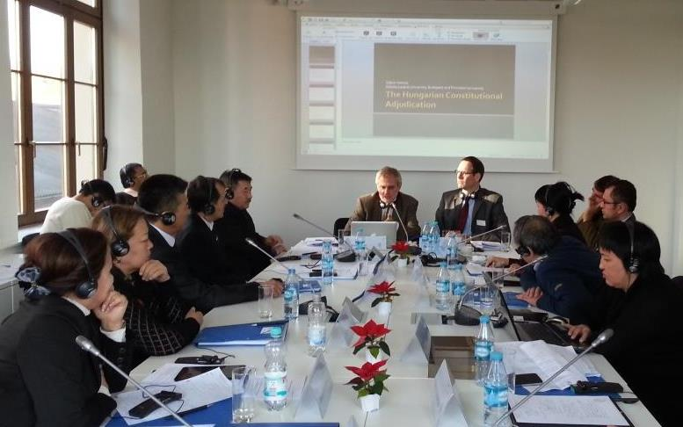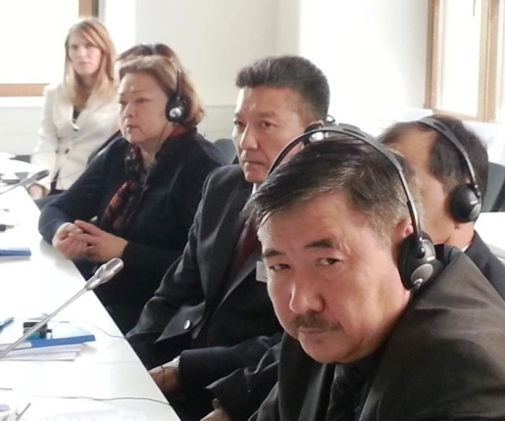

Judges of the CC of the Kyrgyz Republic get acquainted with the history of the constitutional proceedings in Europe

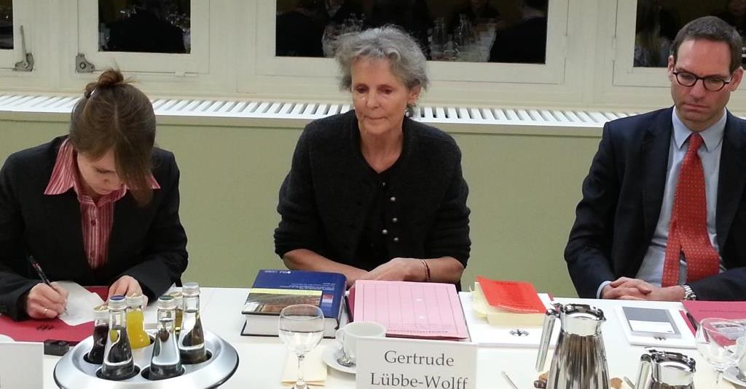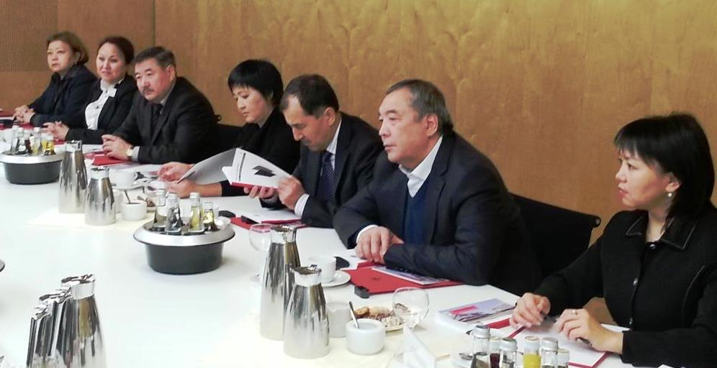

Judge of the German Federal Constitutional Court Prof. Dr. Gertrude Lübbe-Wolff shares her experience with the judges of the CC of the Kyrgyz Republic

***Pictures 26-27 – Meetings in the Austrian Constitutional Court***

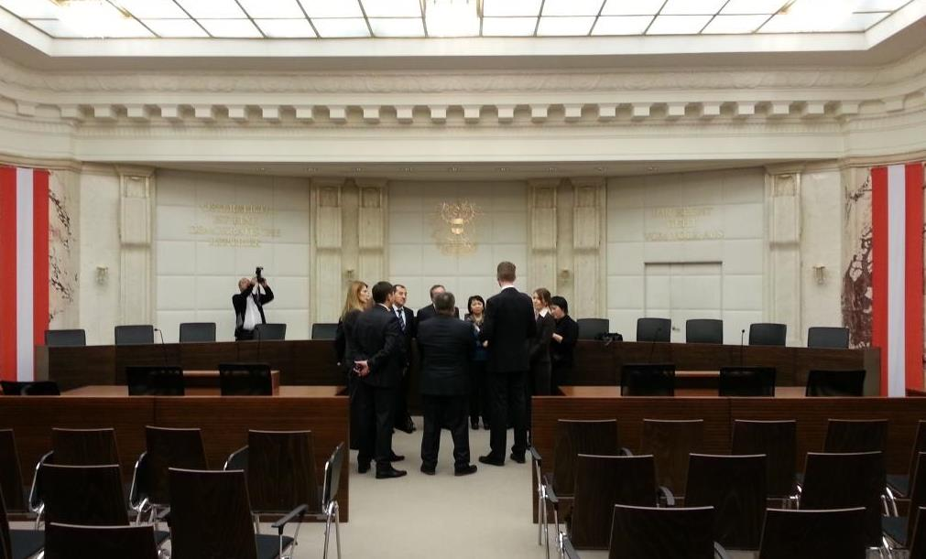

**The Kyrgyz delegation in the sitting room of the Austrian Constitutional court - the principles of its work are manifested in the phrase shown on the picture**

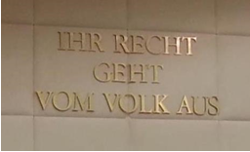

*Constitutional and the Supreme Courts of Spain*

* The second study visit the Kyrgyz delegation focused on the experience of two *Spanish courts (tribunals),* the Spanish Constitutional Court and the Supreme Court, including their practices, history, position in the structure of state power, organization, procedure of election, procedure of appeal, consideration of cases, and other topics. In addition, there was study of the experience of the *Council of Europe* and its institutions, including: the *European Court of Human Rights*, the Parliamentary Assembly, the Committee of Ministers, the Venice Commission, the Congress of Local and Regional Authorities, the European Program for Human Rights Education for Legal Professionals (HELP Program), the Secretariat of the Group of States Against Corruption *(GRECO),* the Consultative Council of European Judges (CCJE), the Consultative Council of European Prosecutors *(CCPE),* and the European Commission for the Efficiency of Justice *(CEPEJ).* In Spain, the participants had the opportunity to visit the Centre of Political and Constitutional Studies of Madrid. The program for the visit was organized jointly by the VC and UNDP: the VC invited quality experts who shared their experience and knowledge, while UNDP contributed to programme, ensured the participation of judges and staff, transportation, and visa support, and helped provide accommodation.

***Picture 28.*** [***Assistance to the Constitutional Chamber of the Kyrgyz Republic***](http://www.venice.coe.int/webforms/events/?id=1944)

<http://www.venice.coe.int/webforms/events/?id=1944>

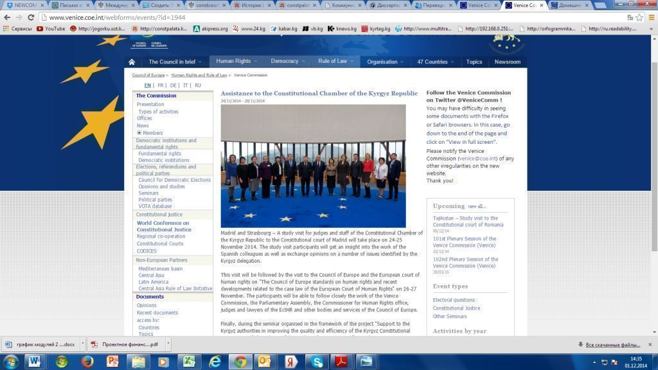

*Constitutional Courts of Latvia and Moldova*

* The third study visit taken November 17-21 was to explore the *experiences of the Constitutional Courts of Latvia and Moldova* and had 14 participants. This visit again allowed the participants to obtain practical information useful and relevant to their work, including information on legislation, organizational structures, interaction with other branches of power, electronic document exchanges, databases, the daily business of subdivisions of the court, press service, communication, training and re-training staff, and international cooperation. The members of the Kyrgyz delegation were made aware of how the staff of other courts write analytical papers and apply international agreements and commitments in their own judicial practices. Indeed, they took away a lot of information that will help in the implementation in their work, such as manual/instructions on writing analytical notes, mechanisms for preparing and agreeing to draft decisions, useful management tools, rules and procedures. With regard to electronic tools, they studied Latvia’s experience on database “CITAVI”, and Moldova’s experience of the judicial decisions database “СС DOC”.

Concerning databases CC made a decision to develop in a short-term period similar IT systems in the Kyrgyz Republic, as well as to implement small but useful software instruments, such as a localized feature that would enable a judge to “chat” in the session hall with his/her legal advisors, the quick exchange of opinions between judges, document conversion, etc. During the visit, the participants received an electronic collection of legal and other working documents which are used in the Constitutional Courts of Moldova and Latvia and which could be referenced in the work of the CC and the Project.

In conclusion, it should be noted that knowledge gained during these study visits as well as accumulated experiences, helped the CC in envisioning similar changes and institutional reforms and will be useful further for their implementation and the acceleration of proceedings.

***Pictures 29-30.Study visits to learn experience of the constitutional courts of Latvia and Moldova***

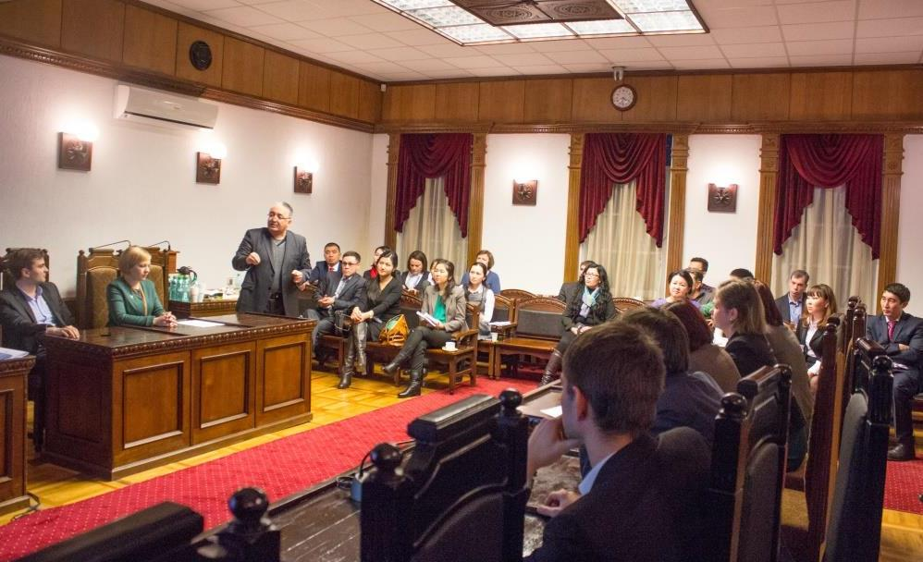**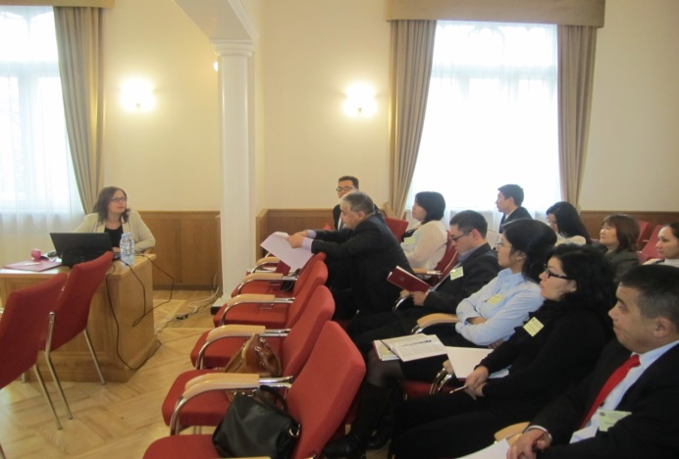**

**СС staff members making exchange of practices with the staff of the constitutional courts of Latvia and Moldova**

*3rd “World Conference on Constitutional Justice”* *(WCCJ)*

The participation of the Kyrgyz CC delegation in the WCCJ in Seoul can be connected to one of the strategic interventions of the Project. The Conference brought together the leaders of constitutional justice authorities from almost 100 countries around the world. The Kyrgyz Republic was represented by a CC delegation headed by its President, Mr. Mukambet Kasymaliev. The conference was hosted by the Constitutional Court of the Republic of Korea. It became the largest event ever attended by the heads of constitutional courts, supreme courts, and constitutional councils. It was noted in the welcoming remarks by the VC President Mr. Gianni Buquicchio that this was an unprecedented event in the history of constitutional justice[[11]](#footnote-11). The conference was attended by the 11th President of the Republic of Korea Park Geun-hye. UN General-Secretary Ban Ki-moon also addressed participants with an on-line welcome speech.

* The main objective of the conference was to discuss the role of constitutional courts in addressing *new global challenges caused by the economic crises* and resulting social problems and conflicts that ought to be solved. In previous years, the role of constitutional courts was mostly confined to the issues of the rule of law and constitutional balances *(that is, the system of checks and balances existing among various branches of power).* While these issues are still important, countries are to a greater extent starting to face other major economic and social challenges as well related to immigration/emigration, hyper-nationalism, the aging of their populations, language disputes, and strains on social safety nets *(i.e.* *social commitments of the government in economic crisis – i.e. pension payments, social guarantees, etc.).* There are also environmental concerns, conflicting views on the wearing of religious attire, etc., which again may contribute to the destabilization of countries and to conflict. Efforts to address these issues all too frequently come at the detriment of other groups, thereby creating new, rather than eliminating, social conflict.
* In such situations, governments and societies have started to more regularly involve constitutional courts in the settlement of disputes these courts have rarely faced before. The role of such institutions in peace-building, conflict resolution, and the promotion of social integration have significantly increased. There is a growing demand not for constitutional courts with traditional foci, but rather for those concerned for so-called “social justice”. The majority of courts in the world, however, have been unable to effectively address these new challenges due to the scarcity of resources and gaps in legislative frameworks. This international conference was aimed at discussing this new global situation and guiding constitutional courts in solving the new challenges confronting them. The participants decided to explore how constitutional courts can respond to such issues and situations in a legitimate and effective manner.
* The international conference attempted to make a review of international judicial practices on these issues *(despite their varying histories and different political, economic, and cultural environments),* summarize their findings, and produce recommendations on how to solve such problems at the national level *(the so called “social minimum and human dignity”).* At the same time, this has to be done without jeopardizing democracy and human rights, by staying within constitutional frameworks and the rule of law, and by avoiding the creation of new conflicts in the society – this is, of course, by no means an easy task.
* To deal with this problem, the Secretariat of the Conference had begun long before the event to develop a questionnaire on sub-topics aimed at exploring existing court practices on these issues, and then sent the document out to constitutional courts in various countries. The responses sent back from courts *(replies to various questions were sent in by 40 to 63 courts)* showed the following:
* first, that these challenges do indeed exist and many institutions have already started to feel the impact of them;
* second, that social unity and integration are perceived by courts as options for solving these emerging problems;
* and third, that some constitutional courts already have some practice addressing them.

The analysis showed that the most viable approach to be used by constitutional courts is to address new emerging problems through the prism of “social integration”. Taking into account the interests of all stakeholders was recognized as a necessary aspect in decision-making in order to mitigate conflict. The majority of participants in the survey stated that earlier approaches, which tended toward the exclusion of the others, are no longer working. New approaches still demand that integration be taken into account; they would prefer decisions based on integration rather than disintegration as integrated groups/communities seem at the same time to be the strongest communities and groups.

* Constitutional courts proposed to expand the range of traditionally considered issues and include issues which are part of the “social list”, and usually considered as social commitments of the government. The are some of the issues added to this list: the provision of shelters and medical services; greater concern for social programs in national budgets *(making available government funds to implement to ensure constitutional rights, decent livelihoods, medical aid, child benefits, etc.;* *immigration; the rights of pensioners in an aging society; environmental issues, increased xenophobia in developed countries resulting from illegal migration; language problems; same sex marriage and other claims for equality; cloning; and stem cell research and use).*
* It should be noted that the organizers also managed to create a discussion platform to cover issues relevant to the performance of constitutional courts. Some of the questions it considered are: How should the court treat social integration and solutions to social and economic problems? What cases should be referred to the constitutional court? What are the limits of its competence, and who defines them? What is the basis for the court’s legitimacy? How can constitutional courts and judges provide support to various groups of with a population? What tools can be used by constitutional courts in handling such cases, without going beyond their competencies? What is the coverage and level of efficiency of constitutional rights in the environment of immigration and integration?
* Various opinions were expressed, and while some were at different ends than others, and the following seem particularly interesting or important:
* Some participants said that the constitutional courts *(hereinafter referred to as “CCs”)* do not have a legal framework for the administration of social justice. Representatives of Peru and Poland expressed their concern that by interfering in this area, CCs would instead *create* problems. Peruvian representatives stated that the limits of such activity of courts are defined by their resources, national constitutions, jurisdictional competencies, emergency situations, and expediency. At the same time, there must be strong external, internal, and self-control of CCs in performing such activities;
* Representatives of Germany said that these problems have to be explored in view of the capacity of courts to handle cases. If there were many social cases, the courts would not be able to handle them. For example, the Federal CC of Germany receives annually roughly 10,000 petitions, yet the capacity of the institution allows it to take up only 6,000. There should not only be a pro-active or limiting approach to their work; ССs have to abide by their country’s constitution and work to protect it;
* Representatives of Ukraine stated that there was a need to take into account the economic and social capacity of the state, as well as to solve individuals’ and the public’s interests while considering the interest of the government, as social commitments of the state depend on its financial capabilities. Some participants said that in the economic crisis it is difficult to ensure equality, the right to education, social safety nets, etc. Many participants stated there was a need for specification more precise definition of the term “social integration”; several countries proposed definitions which they use in their own activities *(for example, the Republic of Korea defines social cohesion as a feeling of affiliation to a certain community, equality, the desire to into society those who are, for various reasons, otherwise excluded or marginalized, while South Africa believes that social integration is inclusion in the social process of those generally excluded).* The CC of the Republic of Korea stated that social integration involves many problems, especially for governments. It puts authorities in an awkward situation, as very often the range of social rights is broader than the one formally prescribed in a constitution; this results in, and can be a cause of, conflicts. Additional social commitments are needed. However, the position of the Constitutional Court of the Republic of Korea will be flexible in order to take into account the opinion of its country’s government, while the court decisions will nonetheless be based on the objectives of social integration and reflect upon tragic situations;
* A large number of CCs supported the idea that the decision of the courts should be rooted in social integration and raised the issue of developing international social integration standards. The courts should work harmoniously to solve social issues as they arise in view of specific features of the country they operate in. The CC of Bolivia stated that courts should be operational and constructively work to produce positive impacts on social integration. Representatives of Brazil felt that the twenty-first century should be marked with the materialization of constitutional rights and that the process of achieving this has to be channelled through constitutional courts. The CC of Albania stated that the legitimacy of constitutional justice institutions depends on how they solve issues related to social integration. Representatives of Sri Lanka raised the issue of environmental equity, arguing that the government has the right to limit the rights of various parties, considering the human being as the most important.
* The participants of the conference discussed instruments that could be used to solve problems of social integration. The following were specifically highlighted:
* A clear distribution and division of various issues between appropriate agents was said to be needed, without one institution assuming the responsibilities that belong to another. For example, some courts said that same sex marriages should not be reviewed by the CCs, as this was an issue for legislatures to address;
* Excessive activism by constitutional courts, and a review of cases taken up on CC’s own initiative, may result in CCs being accused being too political, which may then cause formal disputes between the courts and legislators;
* Adoption by all countries of the International Covenant on Economic, Social and Cultural Rights *(ICESCR),* was also raised, as not all countries are signatories to it;
* A summary of practices and experiences of various countries were brought out, finding common features and the elaboration of international standards *(Côte d'Ivoire, etc.);*
* Introduce effective mechanisms for filtering cases *(as in France);*
* Countries where CCs have the right to review draft laws, received the recommendation to introduce the elements of social integration at this stage. The countries where CCs do not have such a right should have, within the framework of ex-post constitutional review, the possibility to challenge the laws and/or provisions which jeopardize social integration. Within the competencies of the court they can highlight the manifestations of inequality;
* The quick and effective review of appeals in court is also of importance. Promptness of performance in court operations is also a key component in the fight against discrimination and contributes to social integration;
* In the end, there was a general commitment to protect human dignity;
* It was also concluded that social and economic crises should not reduce the level of democracy;
* In addition, participants from courts and international organizations conducted a review aimed at identifying the current status of a country’s court’s independence. The conference raised issues concerning the development of a mechanism of response to violations of the independence of the judiciary in the countries;
* The participants of the Congress adopted the “Seoul Communiqué”, an outcome document summarizing the results of the three-day session. The document also contained a proposal from the President of the CC of Republic of Korea Park Han-chul to promote discussions on international cooperation in promoting human rights, including the possibility of establishing a human rights court in Asia.

***Pictures 31 -34. Joint photo of the conference with Presidents of world courts; Photo with Presidents and judges of six constitutional courts – Latvia, Moldova, Lithuania, Kyrgyzstan, Kazakhstan, Kosovo; After the ceremony of signing Memoranda of Understanding between Kyrgyz and Turkish constitutional courts; Speech by the President of the CC of the Kyrgyz Republic at the world conference***

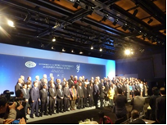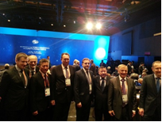 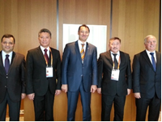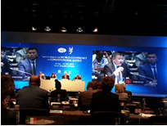

*As a result:*

* Within the short period of the conference, the Kyrgyz judges and staff in attendance received first-hand information, conducted an important exchange of experiences with similar institutions, became acquainted with the global agenda of CCs, and learned how other courts find solutions to emerging challenges;
* The Kyrgyz CC participated in the sessions of two regional- and language-centred groups: a meeting of constitutional control organs of newly democratic countries and a meeting of the Association of Asian CCs and equivalent institutions. At both meetings, the CC provided feedback on questions under review and participated in a joint planning process;
* At the meeting of countries titled “new democracies”, there was an information exchange on current activities between the courts of Armenia, Ukraine, Moldova, Azerbaijan, Russia, Tajikistan, Kazakhstan, Uzbekistan, and the Kyrgyz Republic. The countries scheduled joint plans for the coming year. In particular, the courts agreed to make a regular information exchange with each other on the decisions of their courts, and to make contributions to the bulletins and brochures which are published by each other’s courts. Due to the growing interest in the problems of developing countries, the CC of Armenia has expressed a desire to publish a summary of the practices of the courts of those countries. Further, Armenia proposed to publish a pamphlet themed "The Judges of Constitutional Justice" in which they could share their experiences with judges of constitutional courts. As many courts have the power to make preliminary examinations of international treaties, participants of the “new democracies’ group agreed to exchange experiences in this area as well;
* Kazakhstan proposed to organize a joint event on issues of sovereignty, since several countries plan to join the Customs Union, an issue of growing concern;
* Armenia proposed to create a virtual constitutional court out of members of this group, in order to study the constitutional status of human dignity in all of its aspects *(for the first time, this topic has been raised by the Venice Commission at Montale, where constitutional experts have been identified 14 or 15 main rights related to human dignity)*. It was proposed that the practice of participating countries in this area be examined and summarized, and the practice extend to all courts;
* Direct *(personal)* contacts were established. The direct exchange of information has been conducted with representatives of following organizations:
* Mr. Gianni Buquicchio, President of the Venice Commission of the Council of Europe;
* Mr. Park Han-chul, President of the CC of Republic of Korea;
* Mr. Jugnee Amarsanaa, President of CC of Mongolia;
* Mr. Ricardo Lewandowski, President of the Supreme Federal Court of Brazil;
* Mr. Matti Pellonpaa, Justice of the Supreme Administrative Court of Finland;
* Mr. Alexandru Tanase, President of the CC of Moldova;
* Mr. Aldis Lavins, Chairman of the CC of Latvia;
* Ms. Laila Jursena, Advisor to the President of the CC of Latvia;
* Mr. Danious Zalimas, Chairman of the CC of Lithuania;
* Mr. Alparslan Altan, Vice-President of the CC of Turkey;
* Mr. Zuhtu Arslan, Member Judge of the CC of Turkey;
* Prof. Dr. Ivan Cukalovic, Deputy-President of the CC of Kosovo;
* Mr. Igor Rogov, Chairman of the Constitutional Council of Kazakhstan;
* Mr. Yurii Baulin, Chairman of the CC of Ukraine;
* Mr. Tomas Markert, Director of the Secretariat of the Venice Commission;
* Mr. Schnutz Durr, Secretary of the WCCJ and Head of Constitutional Justice Division of the Venice Commission;
* Mr. Robert Rudolf Husbands of the Rule of Law and Democracy Section, Office of UN HCHR in Geneva;
* Mr. Sello Chloane, Acting Head of Judicial Policy, Research and JSC, South African Constitutional Court;
* Mr. Duishon Chotonov, Ambassador of the Kyrgyz Republic to the Republic of Korea;
* Two MOUs were signed: one between CCs of the Kyrgyz Republic and Moldova, and another between the Kyrgyz Republic and Turkey;
* Agreements on an internship programme and information exchange were reached with Latvia, Moldova, and Turkey *(two of them were implemented after the conference);*
* It was agreed with the President of the Supreme Federal Court of Brazil that he will help the Project in contacting knowledgeable people and organizations in his country to share their experience on amicus curiae. The Brazilian experience in amicus curiae was recognized at the conference as successful and also has been recommended by the VC;
* The Kyrgyz CC reached an agreement with the President of the Constitutional Court of the Republic of Korea to conduct e-communications on the organization of an electronic document exchange. The CC of the Republic of Korea managed to create an exemplary electronic document flow system. A effort to create a similar system is currently on-going in the CC of Kyrgyz Republic. Therefore, information exchange would be very useful and relevant;
* Agreement was reached with a judge from Finland for his assistance in identifying appropriate contacts in the Ministry of Justice of Finland with experience addressing the legal liability of organizations. This experience is now very much in demand in the Kyrgyz Republic;
* Upon return, follow-up actions on agreements reached during the conference were conducted, a roster of contacts created, the experience exchange programme with Moldovan and Latvian courts successfully implemented, and a folder of conference materials was produced for use by the CC and for Project activities.

*Activity 3.10 Conducting one annual workshop for the entire staff (through self-reflection, stock taking, and monitoring of an organizational development strategy)*

This will be conducted in 2015.

*Activity 3.11 Supporting a ‘Judges Training Center’ in order to institutionalize new training on the competence of the CC and international laws/standards for judges and legal professionals based on development and analysis of case studies, simulations/role plays, etc.*

This will be conducted in 2015.

*Activity 3.12. Assisting in the creation of appropriate working conditions (by reviewing and improving infrastructure, improving the courtrooms and the court’s library, and ensuring digitalization of document flow)*

* Some *IT equipment* were procured through an LTA *(long-term agreement)* tender process and handed over to the CC to facilitate more effective internal business processes and discussions. Specifically included were a server, 11 workstations for judges that could be used while in the court room, UPS, an uninterrupted document flow scanner, a copy machine, network data storage, a backup system, and other components;*;*
* The establishment of the *Security Check Point* for the CC in line with security requirements is on-going. Construction estimates and documents were developed and approved by the municipality. It is expected that the Security Check Point will be completed in the spring of 2015;
* The creation of an audio conference system is in process and will be operationalize in 2015;
* In the next phase, several small software solutions will be implemented for the CC, making its work easier and more efficient.

OTHER ACTIONS:

*Project Management*:

* The Project was implemented with an *adaptive management framework* which includes a logframe, an annual work plan and budget, an internal monitoring system with indicators, a risk matrix, and a mid-term evaluation.
* *External mid-term project evaluation* was conducted in accordance with the provisions outlined in the Description of the Action *(DoA).* The evaluation was conducted between October 28 and November 12, 2014, with a field mission to Bishkek and a reporting phase afterwards. Following a competitive bid, Mr. Antonio Castro was selected as the evaluation consultant. This mid-term evaluation was focused on assessing the execution of this EU-UNDP Project from its inception up to October 2014, encompassing all activities that have been implemented under the Project, and an analysis of the status of the three planned results and SOs.

The evaluation was aimed at providing an independent assessment of Project’s relevance, effectiveness, efficiency, sustainability, and impact, and included an analysis of the Project’s contribution to the UNDAF/CDP Outcome #3, which states: “By 2016, national and local authorities apply rule of law and civic engagement principles in provision of services with active participation of civil society”. It also explored possible areas of improvements to be introduced during the remaining Project time and identified useful lessons learned and best practices from the experience gained during the implementation. Further, it provided clear and forward-looking recommendations for effective and realistic strategies UNDP and its partners can take that will help them continue the assistance they’ve provided so far. The primary audience of the evaluation report included the UNDP Core Office *(CO)* and PMU, the EU Delegation to Kyrgyz Republic, the CC, and other Kyrgyz and international stakeholders.

The following findings were produced by the evaluation:

* The Project was determined to be highly relevant; it is aligned with country’s needs and priorities as spelled out in strategic documents such as the Constitution, the National Sustainable Development Strategy for the Kyrgyz Republic, the National Judiciary Reform Concept, and the State Target Programme “Development of the Judicial System of the Kyrgyz Republic for 2014-2017”. Furthermore, the Project is aligned with EU and UNDP priorities for the sector. All Project activities, outputs, and approaches are fully respondent to the CC’s needs and tailored to its capacity level and priorities;

* Project content has been successfully confirmed during implementation. Its logic was assessed as valid, clear, and well formulated; the Project rationale and goals were precisely defined, and the approach that was selected are deemed fully adequate by indications retrieved during the field phase;
* The evidences collected confirmed a good level of ownership enjoyed by the Project by its primary beneficiary, the CC, and to a lesser extent by secondary beneficiaries. The CC’s participation is active, with it being involved in planning, implementation, the dissemination of results, and the spreading of knowledge among stakeholders and the public. Ownership of the CC is gradually increasing and becoming more proactive in comparison to the early stages of the Project, and hopefully will continue to grow;
* The Project is a rather challenging one because of its potential political implications; the difficulties faced during implementation proved that the assumptions and risks specified were properly identified. Six assumptions of the Project were found to be highly relevant and, to some degree, portrayed the situation at the start but also basically sketching the Project’s work after one year implementation. As for the 10 potential risks identified, some had indeed materialized, including political interference and some delays;
* Engagement of UNDP as the Project implementing partner gave the Project access to and benefit from UNDP’s inherent organizational comparative advantage, its technical expertise, its program approach to the sector, its access to the Kyrgyz institutions, and its neutrality of agenda;
* The Project closely cooperated with the “twin” EU-VC Project, which are implemented in conjunction with one another, with complementary approaches and while ensuring the sharing of international and national practices. This has facilitated access to international experiences, incorporation into the national/institutional agenda, and enrichment of international practice with the sharing national success stories. The combination of inputs from both Projects through joint activities also ensured cost-efficiency;
* The evaluation has registered the achievement of various intermediate effects/results, including strong visibility of the CC and transparency of its operations, perceived improvements in the CC’s capacity with indirect positive influences on its independence. Moreover, there are firm indications that most of these intermediate effects are likely to be turned into tangible results;
* However, the execution /start of several activities was delayed by objective reasons, most of which were caused by external factors, dependence on decision making, but also the small capacity of the local services market which prolonged tender and retender processes and the weak capacities of other stakeholders who were supposed to contribute to different initiatives of the Project. Due these factors, by the time of the report, 45% of funds were used with 75% of Project time having elapsed. Potential consequences of this situation – high concentration of Project activities in the last four-five months of the Project, absorption capacity of judges and staff and chances that some of the funds will be not used;
* Corrective actions and recommendations were provided by the Evaluation. UNDP and the CC were advised to strongly and jointly advocate to the EU for a no-cost extension.

*Project Steering Committee*

A *Project Steering Committee (SC)* has been set up to guide and review Project implementation, which is composed of the representatives of the EU, UNDP, the VC, and the CC. According to Project design documents, the SC had to be convened at least three times. By the end of 2014, two SCs had been convened: the first SC meeting was conducted on March 12, 2014 and the second on December 11, 2014.

***Picture 35. Steering Committee meeting, March 12, 2014***

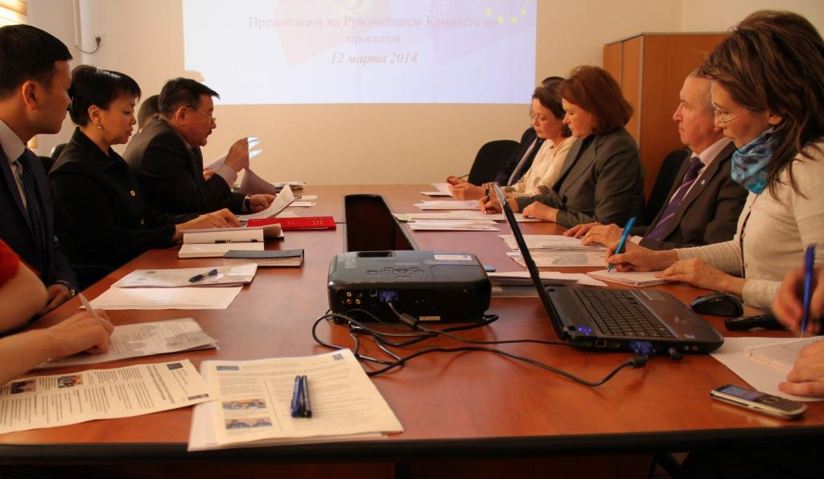

At the most recent SC meeting, participants discussed the results of quadrilateral cooperation, listened to the presentations of Project managers, reviewed the findings of the mid-term evaluation, and discussed plans for 2015.

The meeting was attended by the Chairman of the CC Mr. Mukambet Kasymaliev and three judges of the Chamber, Ms. Chynara Aidarbekova, Ms. Klara Sooronkulova, and Ms. Meergul Bobukeeva. Also in attendance were UNDP Resident Representative in the Kyrgyz Republic Mr. Alexander Avanessov, Ms. Claudia Hock from the Delegation of the European Union, as well as Project staff. Ms. Svetlana Anisimova, the Project manager from the Venice Commission of the Council of Europe, participated in the meeting through an internet-based video-conference link.

The Chairman of the CC Mr. Mukambet Kasymaliev highlighted during the meeting the importance and timeliness of the support provided by the international partners. This support was provided to the Chamber since the very first months of its operation and facilitated within a short time period the understanding and even partial application of international experiences in constitutional justice practice. “**This is important for us, as it allows the exchange of experiences with a large number of experts, resulting in positive changes in the work of the Constitutional Chamber”, Mr. Kasymaliev said.** He also stated that the Chamber deliberately chose a new approach aimed at increased efficiency and transparency in order to better meet the expectations of the public.

On the whole, the SC made a positive assessment of results so far achieved. However, the SC members stressed that the Project was developing in a clear political environment; its further implementation requires constant monitoring of political influence on it and adapting the schedule and activities as necessary. A major issue has been external pressure and intimidation of judges *(use of so called “telephone justice” which envisages the supremacy of the “telephone” and not the law);* the upcoming Parliamentary elections, scheduled to take place in October 2015 are drawing out clear intentions of different political forces to change the Constitution in order to strengthen and prolong their stay in power, despite the fact that, during the referendum conducted in 2010, the Kyrgyz nation voted for the prohibition of any amendments to Constitution until September 1, 2020*.* All these obstacles and the continuous race for power disrupt the activities of the Chamber and distract its attention from its regular work. Understandably, some activities have been postponed due to the unavailability of key partners, or because of the need mitigate the risk of a political/partisan use of the Project's activities and resources. The SC advised that the Action be given a longer duration in response to the disturbance of its activities due to the aforementioned factors. In addition, all SC members stressed that, with the upcoming elections and possible pre-term constitutional reform, constitutional debates in society and the number of applications to the CC will significantly increase. Accordingly, demand for the services of the CC will also strongly increase – leaving the CC without necessary donor support at this moment would not be strategic.

Based on all of this and in order to reach the objective of this Project, the SC decided that a no-cost extension of the duration of the Project as authorized by article 6.2 of IfS Regulation *("in case of objective and unforeseen obstacles to their implementation").* The Project was instructed to take actions necessary for this.

* 1. *If relevant, submit a revised Logframe, highlighting the changes.*

*Please list all contracts (works, supplies, services) above € 60 000 awarded for the implementation of the action during the reporting period, giving for each contract the amount, the award procedure followed and the name of the contractor.*

There is no need to list contracts above € 60,000, as we did not have contracts exceeding this amount.

* 1. *Please provide an updated action plan****.*** [[12]](#footnote-12)

This action covers 18 months period. Project preparing addendum on no-cost extension.

|  |  |  |  |  |  |  |  |  |  |  |  |  |  |  |  |  |  |  |  |  |
| --- | --- | --- | --- | --- | --- | --- | --- | --- | --- | --- | --- | --- | --- | --- | --- | --- | --- | --- | --- | --- |
| **Activities** | **Year 1** | | | | | | | | | | | | **Year 2** | | | | | | | **Implementing body** |
| **Semester 1** | | | | | | **Semester 2** | | | | | | **Semester 3** | | | | | | |
| 1 | 2 | 3 | 4 | 5 | 6 | 7 | 8 | 9 | 10 | 11 | 12 | 13 | 14 | 15 | | 16 | 17 | 18 |
| **Preparation, inception phase** |  |  |  |  |  |  |  |  |  |  |  |  |  |  |  | |  |  |  |  |
| **Output 1. Create an enabling environment for the smooth operationalization of the CC and for effective constitutional justice** | | | | | | | | | | | | | | | | | | | | |
| 1.1. Assisting working process of the CC in drafting/amending of relevant laws, and by-laws and addressing vagueness of legal proceedings *(preparing for further legal opinions by experts of the Venice Commission);* |  |  |  |  |  |  |  |  |  |  |  |  |  |  |  |  | |  |  | Constitutional Chamber |
| 1.2. Gaining support from main actors and stakeholders *(the MPs of the Parliament, the President's Office, Government, Courts, CSOs, other decision-makers and intelligent visionaries)* by informing and providing them strategic advice on the roles, functions and procedures of the CC; encouraging engagement of stakeholders in discussions about check and balances, power imbalance, and other important issues in the national context *(workshops, roundtables, conferences, consultations, articles, presentations, etc.);* |  |  |  |  |  |  |  |  |  |  |  |  |  |  |  |  | |  |  | Parliament, President's Office, CSOs, etc. |
| 1.3. Provide support to expedite selection process of vacant CC seats |  |  |  |  |  |  |  |  |  |  |  |  |  |  |  |  | |  |  | Constitutional Chamber, Parliament, President |
| 1.4. Conduct meetings at policy levels jointly with the experts of the Venice Commission; |  |  |  |  |  |  |  |  |  |  |  |  |  |  |  |  | |  |  | Constitutional Chamber, Parliament, President, Government |
| 1.5. Provide support to ensuring financial independence of the CC; |  |  |  |  |  |  |  |  |  |  |  |  |  |  |  |  | |  |  | Constitutional Chamber, Parliament, Government, CSOs |
| 1.6. Assisting creating sustainable enabling environment through civic engagement, amicus curiae, civic monitoring, social surveys on implementation of courts decisions and etc.; |  |  |  |  |  |  |  |  |  |  |  |  |  |  |  |  | |  |  | Constitutional Chamber, CSOs, LSGs, Legal professionals, universities |
| 1.7. Assist in communicating annual reviews to the Parliament, the office of the President, the Government, and civil society |  |  |  |  |  |  |  |  |  |  |  |  |  |  |  |  | |  |  | Constitutional Chamber, Parliament, President, CSOs, LSGs, Legal professionals |
| 1.8. Providing support to the establishment of a critical mass and awareness in the constitutional justice in the community of legal experts which includes legal professionals, bars, judges, universities *(conducting mini-workshops, problem discussions, trainings, creating legal advisory board* *or specialized consultative and analytical centre as requested by the CC);* |  |  |  |  |  |  |  |  |  |  |  |  |  |  |  |  | |  |  | Constitutional Chamber, Parliament, Courts, President, CSOs, LSGs, Legal professionals, Bars |
| **Output 2. Assist with establishing effective communication processes to highlight improved CC performance and raise public perception** | | | | | | | | | | | | | | | | | | | | |
| 2.1. Assisting with interaction between the CC and CSOs, Courts, other stakeholders, establishing an inclusive dialogue platform for engagement of stakeholders to provide timely feedback to improve CC performance |  |  |  |  |  |  |  |  |  |  |  |  |  |  |  | |  |  |  | Constitutional Chamber, Parliament, Government, CSOs, LSGs, Legal professionals, universities, media |
| 2.2. Providing support to the development and implementation of the communication/outreach strategy and plan; conducting workshops for relevant staff and judges to implement this; |  |  |  |  |  |  |  |  |  |  |  |  |  |  |  | |  |  |  | Constitutional Chamber |
| 2.3. Enhance the capacity of the press service and provide continuous TA following up the media trainings for the judges of the CC conducted by the Venice Commission |  |  |  |  |  |  |  |  |  |  |  |  |  |  |  | |  |  |  | Constitutional Chamber |
| 2.4. Improve CC’s reporting requirements and standards |  |  |  |  |  |  |  |  |  |  |  |  |  |  |  | |  |  |  | Constitutional Chamber, media |
| 2.5. Ensuring transparency and efficiency of the CC by usage of ICT applications, design and pilot a web-site; |  |  |  |  |  |  |  |  |  |  |  |  |  |  |  | |  |  |  | Constitutional Chamber |
| 2.6. Support easy-to-read publications, leaflets and infographics for the public; |  |  |  |  |  |  |  |  |  |  |  |  |  |  |  | |  |  |  | Constitutional Chamber, sub-contractors |
| 2.7. Conduct baseline and follow-up surveys; |  |  |  |  |  |  |  |  |  |  |  |  |  |  |  | |  |  |  | Constitutional Chamber, sub-contractors |
| **Output 3. Assist to institutional and individual capacity building that helps the CC in accomplishing its mission** | | | | | | | | | | | | | | | | | | | | |
| 3.1. Conduct initial orientation training programme for judges and staff *(with involvement of the VC experts);* |  |  |  |  |  |  |  |  |  |  |  |  |  |  |  | |  |  |  | Constitutional Chamber, Venice Commission, local experts |
| 3.2. Providing support in the development of organizational development strategy which is discussed with stakeholders and presented to the public; |  |  |  |  |  |  |  |  |  |  |  |  |  |  |  | |  |  |  | Constitutional Chamber, sub-contractors |
| 3.3. Conducting tailored trainings and individual coaching for judges, staff, different units of the CC which includes human rights, gender sensitization, minority and representation, international agreements and conventions, conflict-sensitivity, leadership, management, ICT, language, team-building aspects; |  |  |  |  |  |  |  |  |  |  |  |  |  |  |  | |  |  |  |  |
| 3.4. Providing support to the building of a powerful management team capable of running a CC that accomplishes its mission; providing support to the streamlining and optimization of business processes; |  |  |  |  |  |  |  |  |  |  |  |  |  |  |  | |  |  |  |  |
| * 1. Improving human   resource management; |  |  |  |  |  |  |  |  |  |  |  |  |  |  |  | |  |  |  |  |
| * 1. Supporting the   drafting of necessary institutional policies; |  |  |  |  |  |  |  |  |  |  |  |  |  |  |  | |  |  |  |  |
| * 1. Following up the case   management training conducted by the Venice Commission provide support practical to implementation of case registration system, for the creation of standardized forms and the design of file folders for the registrar; |  |  |  |  |  |  |  |  |  |  |  |  |  |  |  | |  |  |  |  |
| * 1. Addressing issues related   to working languages of the CC and transcripts of proceedings; |  |  |  |  |  |  |  |  |  |  |  |  |  |  |  | |  |  |  |  |
| * 1. Organizing study tours   to relevant host countries on the issues of institutional development, support networking *(engagement of the CSOs, universities and legal practitioners is essential);* |  |  |  |  |  |  |  |  |  |  |  |  |  |  |  | |  |  |  |  |
| * 1. Conducting one   annual workshop for the entire staff *(self-reflection, stock taking, and monitoring of organizational development strategy);* |  |  |  |  |  |  |  |  |  |  |  |  |  |  |  | |  |  |  |  |
| 3.11. Supporting a ‘Judges Training Center’ in order to institutionalize new training on the competence of the CC and international law/standards for judges and legal professionals based on development and analysis of case studies, simulations/ role plays, etc.*;* |  |  |  |  |  |  |  |  |  |  |  |  |  |  |  | |  |  |  |  |
| 3.12. Assisting in the creation of appropriate working conditions *(review and improve infrastructure, improve the courtrooms and the court’s library, and ensure digitalization of the document flow).* |  |  |  |  |  |  |  |  |  |  |  |  |  |  |  | |  |  |  |  |

1. BENEFICIARIES/AFFILIATED ENTITIES AND OTHER COOPERATION
   1. *How do you assess the relationship between the beneficiaries/affiliated entities of this grant contract (i.e. those having signed the mandate for the Coordinator or the affiliated entity statement)? Please provide specific information for each beneficiary/affiliated entity.*

The main Project beneficiary is the Constitutional Chamber. According to the relevant constitutional law, which regulates the CC’s functions, the CC is the highest judiciary authority and independently performs constitutional oversight by way of constitutional legal review. The beneficiary institution is a compact organization, comprised of judges and its secretariat *(“the administration”).* The names of potential judges are first chosen by the Council on the Selection of Judges, and are then submitted to the President, who forwards the nominations to the Parliament. The Parliament then elects judges from these nominations at its plenary session. At present, there are eight judges and three vacant seats*.*

The Project was able to establish reliable relations with the beneficiary institution and to ensure that the judges of the CC and its staff had a strong sense of ownership in its processes. We strive to foster competent and honest relations with beneficiary agencies, share information, demonstrate best practices, and diplomatically and respectfully discuss any problematic issues. The beneficiary sees the EU and UNDP as trustworthy partners who provide high-quality expertise, consultancy, and organizational support. We also managed to establish good partnerships with various CC departments and all judges. The CC is actively participating in all aspects of the Project, including its planning and the direct implementation of activities, contributing to the dissemination of results and the further spreading of knowledge. Ownership by the CC is one of the factors contributing to the success of the Project’s implementation; indeed, without the beneficiary’s own motivation and support, it would not be possible to achieve good results.

All these facts were confirmed in the mid-term evaluation’s findings, which were based on collected evidence.

* 1. *How would you assess the relationship between your organization and State authorities in the Action countries? How has this relationship affected the Action?*

In general, the relations with other state institutions have been positive. Maintaining such relations has always been strength of UNDP, and we have taken advantage of it. UNDP managed to establish good cooperation with various governmental institutions, as well as with non-governmental stakeholders in the Kyrgyz Republic. UNDP had established reliable links based on previous beneficial cooperation with the Parliament, the Office of the President, the Government, the Procuracy, the Ministry of Justice, the Judicial Department, the National Statistical Committee, and other entities. It is also worth mentioning that good relationships between the current Project and the Parliament, Ministry of Justice, and President’s Office stems from long-term cooperation between EU and UNDP and between USAID and UNDP, as well as the success of the joint EU‑UNDP Parliament/Constitutional Reform Project implemented in 2007-2010, the New Legal Framework Project implemented in 2010-2012, and the Budget Transparency Project implemented in 2012-2014.

All these connections forged earlier proved to be useful for the current Project as well, for example by helping us gain parliamentary support for various bills. The Government and the Ministry of Finance provided methodological support in the formulation of the first programmatic budget of the judicial system also, and the Office of the Government of the Kyrgyz Republic assisted in included provisions related to the enforcement of decisions of the Chamber, as well as with a large package of bills related to the judicial system which are currently in process. Indeed, all of these institutions actively participate in the Project’s interventions and make meaningful contributions. There are a couple of positive examples of decisions made by the CC actually being executed, with the Parliament and the Government having revised their activities and changing normative and legal acts in line with such decisions. The Project helps these organs to understand the role and the functions of the Chamber, and highlights how they should respond to the decisions of the CC and how the decisions should be implemented. This advice produces results: it helps fill the existing information gap and gradually changes the perceptions and practices of all parties.

At the same time, the political difficulties faced by the Project should not be overlooked. Among these difficulties are those related to the CC’s review of the decrees adopted by the provisional government in 2010, which dealt with the separation of powers, competencies of various institutions, and branches of power, nationalization, etc. These are very delicate issues in the Kyrgyz context, as they are related to the powerful interests. Regrettably, these issues have not yet been settled, and the country still sees a struggle between powers. Occasionally, they disapprove of the decisions pronounced by the Chamber; in fact, there were cases when the President, its Administration, some key members of the Parliament, and the Office of the Prosecution took a very negative stance in respect of the decisions of the Chamber, urging not be abided by. Sometimes, they even try to intimidate the institution, calling it a “detrimental agency”, which, as they say, does not protect the interests of those “who gave their lives for the revolution of 2010” *(the so called “revolutionaries”)*. These kinds of attacks, which have been made on several occasions, have resulted in the suspension of the CC’s regular activities, with the CC attempting to withdraw from the public eye altogether. It also suspended all the joint activities with the Project at a point until the tension eased.

In such situations, neutral support and advocacy on behalf of the Project were also of relevance. They helped relieve the tension, assisted in getting necessary advice, and mobilized support from civil society, prominent social and political actors, and experts.

* 1. *Where applicable, describe your relationship with any other organizations involved in implementing the Action:*
* *Associate(s) (if any)*
* *Contractor(s) (if any)*
* *Final Beneficiaries and Target groups*
* *Other third parties involved (including other donors, other government agencies or local*
* *government units, NGOs, etc.)*

The Project developed many constructive and successful cases of interaction and synergy with other organizations. We are quite aware of the fact that such important and sensitive projects cannot be implemented alone. Such synergy is also of importance for our beneficiary, the CC, as it helps to create a more favourable environment for its own activities, making sure that it is not isolated without support from civil society, representatives of legal professions, the media, and donors.

Knowing these benefits, the Project actively cooperated with various institutions and donor projects which have the same goals, objectives, and values, sharing with them our information, resources, and responsibility.

Several well-known lawyers, constitutional experts, NGOs, human right defenders, university sub-departments, media organizations, and journalists have been involved in Project activities, including the NGOs Precedent, Institute for Public Analysis, Civic Monitoring Over Judiciary Reform, Our Right, Kyz Aiym, Coalition for Democracy and Civil Society, Bars, Association of lawyers, Association of Civil Society Support Centers, and others. The Project is closely cooperating with the editors in chief and journalists from different media organizations.

We also have normal contractual relationships with partners and sub-contractors helping to implement the Project.

* 1. *Where applicable, outline any links and synergies you have developed with*

*other actions.*

The Project considers its Project actions as an integral part of a holistic process of democratic transition, good governance, and the rule of law in the Kyrgyz Republic. As such, it establishes effective linkages with other projects and programs carried out by international donors and organizations, such as the Venice Commission of the Council of Europe, the IDLO/USAID project providing support to judiciary system, the new GIZ/EU initiative on RoL, the Soros Foundation Legal Programme, OHCHR programs, OSCE, UNODC, the Office for Promotion of Parliamentary Democracy of the European Parliament, PACE Rapporteur to Kyrgyzstan, etc. The Project is part of the RoL DPCC, is coordinating its work with other partners' initiatives, and periodically provides information to DPCC members.

We are also cooperating and coordinating activities with other UNDP RoL Projects implemented in the Kyrgyz Republic *(for example, with the projects* ***“****Widening Access to Justice for Legal Empowerment in the Kyrgyz Republic” funded by the Finnish Government and “Enhancing the RoL and its implementation in the Kyrgyz Republic” funded by BCPR*), as well as with UN Peace Building Fund projects, and those with Democratic Governance, Environment, and Social and Economic Development.

All of these partnerships have proved to be mutually beneficial.

We especially want to mention the Project’s cooperation with the funding organization, the European Union. Reliable working relations with the EU Delegation in Bishkek that were created through previous endeavours have been maintained and have helped in the implementation of this particularly challenging Project. We enjoy the support from the EU Ambassador to the Kyrgyz Republic, the EU Project Manager, and other EU Project Managers. Despite their already heavy workload, they always find time to discuss Project issues and provide timely feedback and consultations. They also participate in different Project actions and professionally ensure EU’s representation, share information on the EU and its strategy for Central Asia, the European Parliament, and the Council of Europe.

* 1. *If your organization has received previous EU grants in view of strengthening the same target group, in how far has this Action been able to build upon/complement the previous one(s)? (List all previous relevant EU grants).*

The current Project builds on previous cooperation and EU grants and, to a certain extent, strengthens the same target group, complements previous actions, and raises them to higher levels. The following EU grants were previously received:

2007 - Support to improved transparency in the decision-making process, and institutional strengthening of the Kyrgyz Parliament *(a six-months Project running from February 14 to August 14, 2007 and funded by IfS in the amount of EUR 500,000)*

The Project enhanced transparency in decision-making in the Parliament, improved its law-making and outreach capacities, designed a website, and established an electronic database of bills *(a bills tracking system),* which are in use by the Parliament and the country still. The database is accessible to members of the Parliament, the parliamentary staff, the Government, and citizens. A more reliable electronic voting system in the Parliament was created as well, and is also still utilized.

2008-2010 *-* Support to the Constitutional and Parliamentary Reforms in Kyrgyzstan *(a 24-month Project)*

This EU-funded Project was implemented in August 2008 and ended in August 2010. Its main focus was on parliamentary law-making, oversight, and outreach. The Project established many long-lasting products and results, includingthe establishment of an electronic document exchange *(EDE)* system in the Parliament, the conduct of an orientation training for 87 MPs, and the creation of the Parliamentary radio. All of the results of these efforts are used by the Parliament. Many the MPs who benefited from the training mentioned here became real decision-makers in different areas.

After the April 2010 events and severe ethnic conflict, the Project had to re-shape its activities, though the objective of the Project remained the same. Available funds were re-oriented to support Constitutional reforms which resulted in the drafting of a good constitution for the parliamentary republic and in transparency and openness of the constitutional process. Informed choice of the people during the referendum of 2010 was ensured. The Constitution adopted by popular referendum is still valid. It has been sustained for almost five years, which is a record for the Kyrgyz Republic; all previous Constitutions operated for no longer than two or three years and were frequently amended.

2010-2012 - Institutional support to implementation of a New Legal Framework in the Kyrgyz Republic *(an 18-month project)*

This EU technical assistance provided institutional, legal, and financial support to the main actors implementing the reform program linked to the development of the new legal framework. Three specific objectives were within the action: aligning legislation with the Constitution; increasing the efficiency of state oversight to ensure greater accountability; and reinforcing and modernizing institutional capacities of selected institutions – the Ministry of Justice, the Parliament, the Chamber of Accounts *(CoA)*, the Ombudsman, and eventually Civil Society institutions. The Project added efficiency and speed to the beneficiary agencies’ operations, helped them to professionally address challenges facing the country to re-gain popular trust in the state, which had decreased in the years previous, and positively contributed to stability.

The Project helped the Parliament and the Ministry to draft and amend 37 bills and strategic documents in line with Constitution. These documents included laws on the three branches of power *(judiciary, executive and legislature)* and their interaction*,* local self-governments, the electoral system, and other matters. Thirty-four of these bills were adopted by the Kyrgyz Parliament. These laws laid the foundation for deep political and structural changes in the country. They helped shape the roles of recently established institutions, ensured new content and forms, provided better clarity in their activity, and guaranteed checks and balances and the principles of the rule of law.

1. **VISIBILITY**

*How is the visibility of the EU contribution being ensured in the Action?*

The visibility of the Project activity and the EU contributions was ensured in accordance with the EU Visibility guidelines, which have always been taken into account and properly respected within the framework of the Project.

The key partners of the Project are aware of the role and contributions of the EU and UNDP. They are also duly informed about the goals and objectives of the Project, as well as the methods and tools to support processes and activities within the intended mission. In their introductory speeches, they make reference to the participation of the Project, to the EU as its funding organization, and to UNDP as implementing partner.

To ensure donor visibility in the events, desk flags of the EU, UNDP, and the Kyrgyz Republic are displayed. The Project also has designed special presentation products which include notepads, a handouts template, and banners bearing logos of the EU, UNDP, the Project title, as well as titles reflecting the involvement and the role of other donors. These products are regularly caught by television cameramen filming functions. When events are organized in partnership with the VC, the logo of Council of Europe and VC are also displayed.

There is a sufficient level of recognisability and awareness of the Project in the beneficiary institution, the Parliament, and the President’s Office, NGO circles, legal professions, and the donor community. The partners value greatly the interventions of the EU and UNDP, and during joint event presentations they typically highlight the positive role played by the EU and UNDP in supporting the CC and judiciary reforms in the Kyrgyz Republic.

All printed materials, publications, software, and video products manufactured with the support of the Project have a clear indication of the EU and UNDP contributions, as well as the copyright notice. Press releases, information materials, and articles contain information on the Project and the donor.

Many of these “visibility items” developed by the Project are currently being used by the beneficiaries, NGOs, stakeholders, and partner donor institutions.

In 2014, contributions to better visibility were made by high-ranking officials of the EU and UNDP, among them the EU Ambassador to the Kyrgyz Republic Mr. Cesare de Montis, the UNDP Permanent Representative in the Kyrgyz Republic Mr. Alexander Avanessov, the Deputy UNDP Resident Representative Mr. Pradeep Sharma, and the Director of the Secretariat of the VC of the Council of Europe Mr. Thomas Markert. They traditionally mention the Project and its inputs during their meetings with the political leadership of the Kyrgyz Republic, including meetings with the President, the Speaker, and the Prime Minister. This support has always been useful, as it raises the status of events and more vividly demonstrated the inputs from donors.

**The European Commission may wish to publicize the results of Actions. Do you have any objection to this report being published on the Europe Aid website? If so, please state your objections here.**

There are no objections.

Name of the contact person for the Action:

Pradeep Sharma, UNDP Deputy Resident

Representative in the Kyrgyz Republic………………………………………………………………

Signature: …………………………………………………….………………………………………

Location: Bishkek, Kyrgyz Republic ………………………..………………………………………

Date report due: February 2015……………………..…………

Date report sent: February 2015…………………………….

Prepared by UNDP:

Gulmira Mamatkerimova, Programme Advisor/Project Manager

Supported by team of motivated and capable project experts and specialists:

Irina Letova, Judiciary Expert

Kurmanbek Turdaliev, Parliamentary Expert;

Azamat Egizbaev, IT Expert

Karybek Djigitekov, Legal Expert

Elnura Turgunbekova, Budget Expert

Olga Petrova, Project Finance Assistant

Altynai Akmatova, Media Expert

1. The Chairman of the Constitutional Council of 2010, head of its sections on fundamental rights and system of check and balances between the President, the Parliament, the Government; at present, also the leader of the Ata-Meken parliamentary faction and the so called “father of the Constitution” [↑](#footnote-ref-1)
2. Head of the Secretariat of the Constitutional Council of 2010, and currently the Head of the Office of the President [↑](#footnote-ref-2)
3. Member of the Constitutional Council of 2010 [↑](#footnote-ref-3)
4. Member of the Constitutional Council of 2010, and now the head of “Precedent” partner group [↑](#footnote-ref-4)
5. As later became clear, the Council for the Selection of Judges announced a competition for the vacant positions of judges of the CC. Deadline - February 10, 2015 [↑](#footnote-ref-5)
6. Judges, members of the Council of Judges, mid-rank leaders, judicial experts, and financial specialists [↑](#footnote-ref-6)
7. An “amicus curiae”, a Latin term literally meaning “friend of the court”, is someone who is not a party in a case before a court, but who offers pertinent, unsolicited information or advice. They are resources used in many countries’ legal systems, and their advice may take the form of a written [legal opinion](http://en.wikipedia.org/wiki/Legal_opinion), [testimony](http://en.wikipedia.org/wiki/Testimony), or [learned treatise](http://en.wikipedia.org/wiki/Learned_treatise) *(an “amicus brief”)* to introduce concerns, assist the court by expounding the law impartially, or, if one of the parties is unrepresented, advance legal arguments on that party’s behalf. Where a case may have implications beyond the parties immediately involved, amicus curiae briefs are a standard manner for introducing outside concerns, as they function to ensure that the possibly broad legal effects of court decisions will not depend solely on the parties directly involved in that case. Amicus curiae organizations frequently submit briefs to advocate *for* or *against* a particular legal position or interpretation. For example, if a decision on a matter before a court could affect an entire sector or a large section of society, organizations other than the litigants may wish to have their concerns heard, and therefore choose to submit an amicus brief. Amicus curiae often present an academic perspective on the case, as well; if a law gives deference to a history of legislation on a certain topic, for example, a historian evaluates and critiques the claim on the basis of their specialized historical expertise. An economist, statistician, or sociologist may similarly choose to do the same as amicus curiae when courts are considering topics for which they have particular, and potentially beneficial, knowledge of. In general, while presenting their analyses, the amicus curiae help the courts in determining their positions with the benefit of authoritative, consultative, and intellectual support. In addition, amicus curiae typically conduct awareness campaigns on the issues they are concerned about, thereby helping to strengthen the rule of law, improving the public’s understanding and appreciation of legal issues, and creating a more favorable environment for the operation of the Chamber. [↑](#footnote-ref-7)
8. Since this event is duplicated with activity 1.6, it is recommended that the two events be combined into one. It is also recommended that appropriate adjustments be made to the project work plan and for the EU to be informed. [↑](#footnote-ref-8)
9. This issue will probably become relevant in 2015 within the framework of reviewing the existing ethical code of the entire judicial system and development of the communication strategy. [↑](#footnote-ref-9)
10. There was no possibility to conduct the tender earlier, as the creation of the conference system depended on the completion of the electronic document exchange program, implemented by the IDLO/ISAID project on the judicial system. [↑](#footnote-ref-10)
11. The first WCCJ was conducted in January 2009 jointly with the Constitutional Court of South Africa and the VC (as an advisory body on constitutional matters and secretariat of the world conference). The second conference was conducted in cooperation with the Supreme Federal Court of Brazil in January 2011, and the draft statute of the World Conference was made more specific on that occasion. This draft statute was adopted at a meeting of the Bureau of the World Conference in May 2011, and came into force in September the same year, finally taking shape as a permanent body. The Conference in Seoul was also referred to as the ‘inaugural’ Congress, being the first gathering since the World Conference officially became a permanent body. In its initial stage in 2011, the World Conference had only 30 constitutional courts/councils and supreme courts as members. But within three years, the membership increased dramatically with representation of 91 countries *(as of August 2014);* its members have engaged in active exchange and cooperation since, which has developed the World Conference into the world's highest-level forum on constitutional justice – in the true sense of the term. The participants of the Congress were the highest-level officials with great influence over decision-making in their own countries. It had a total of 306 participants. [↑](#footnote-ref-11)
12. This plan will cover the financial period between the interim report and the next report**.** [↑](#footnote-ref-12)